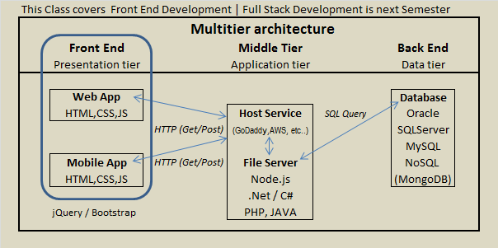
Class 1
Intro to HTML, CSS, and JavaScript
…
Administrative items
We will use the Zoom app for classes until further notice.
How to use Zoom for a virtual class room… be willing to share your screen…
I will need to see your code (from time to time)
My personal Nucamp site: http://www.drpage.net/nucamp/ .
Use it as an additional resource, and to download my lectures.

Today’s class is about HTML, but it is more than just that…
We will cover: Setting up your files, your IDE, how to use VS Code, how Web pages are laid out, important tags (and their attributes), how HTML interacts with CSS and JavaScript, as well as your Week 1 Class Assignment for this week.

Getting started: Create (or open) a Folder called “Nucamp” on your desktop (or somewhere you remember).
Add these sub-folders: “Class1”, “Class2”, “Class3”, “Class4”, “images”, “css”, (“videos” or “music” or “media”) and “js” <= stay organized.
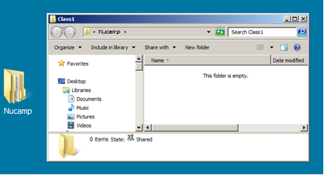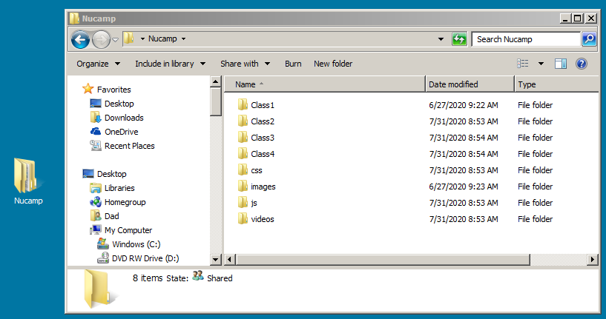
Setting up your PC or MAC with MS VSCode Code <= use these instructions. – Everyone needs to have VSCode running…
Everyone please acknowledge. Are you using a PC or MAC ?

MS VSCode: An integrated development environment (IDE) is software that you can load onto your computer, designed to streamline web development. Visual Studio Code, Eclipse, Dreamweaver, and Aptana, Notepad++ … to name a few…
1) Open a folder in VSCode: File => Open a Folder, then choose Nucamp (or your main folder) from the dialog box. (Don’t open a file only)
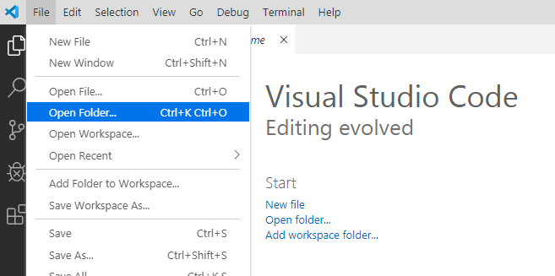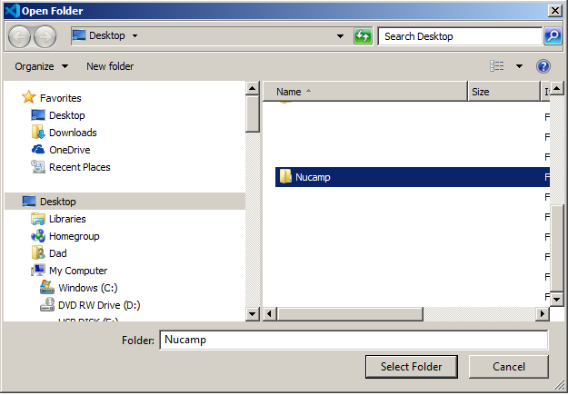

2) After selecting the folder, your IDE should look something like this… Showing the Nucamp folder and 8 sub-folders
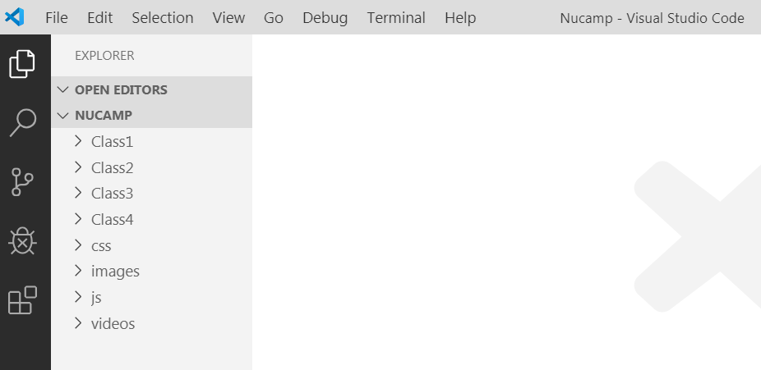
Notice the VSCode short cuts… They will come in very handy as you start developing your code… More about them when we create a file…
3) Create a new HTML file. From the menu select: File => New File
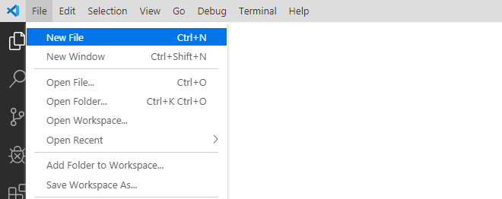

4) You should see an Untitled file:
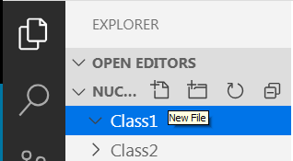
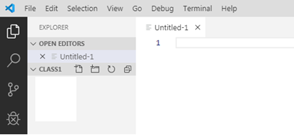
Alternate Method: Click the New File icon, and just type in the name of the file with an “.html” extension.
5) Before creating any code you need to name the file with the HTML extension. File > Save As, then in the dialog box give the file a File Name: something like “home” (no spaces… use Camelback or Underlines – but no spaces. Servers don’t like names with spaces)
then select HTML from the “Save As Type” dropdown list
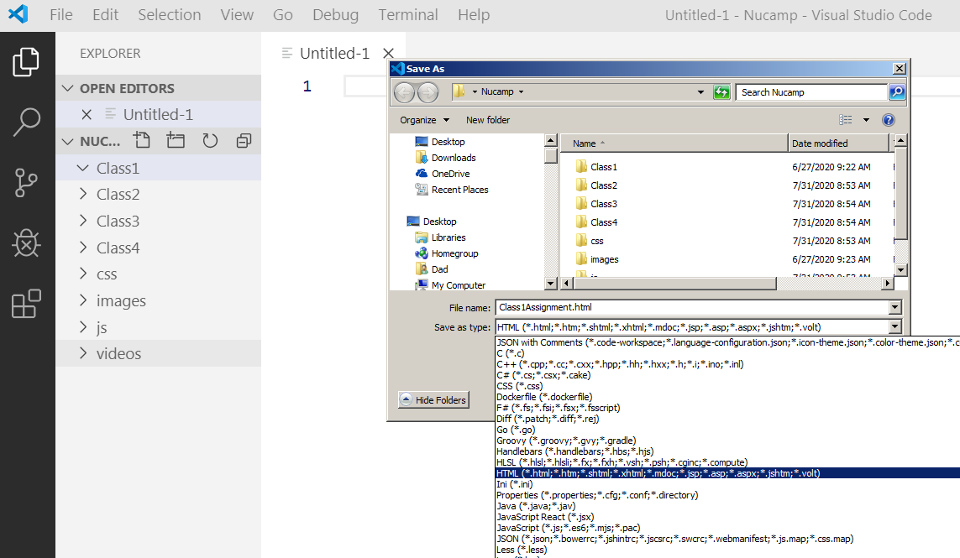

6) Select Save, and you should see the following:
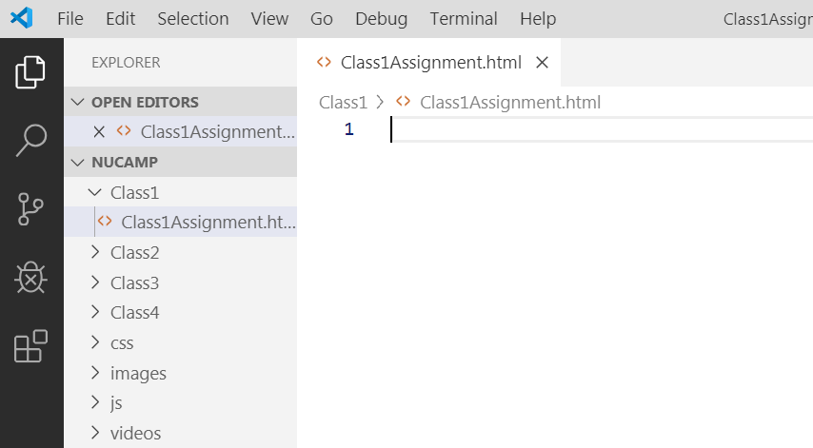
6a) At this point you could start typing code or paste code from another file, but there is a quick short cut… hold down the “Shift” key + ! and you will get an Emmet dialog box with all necessary base code for an HTML page.
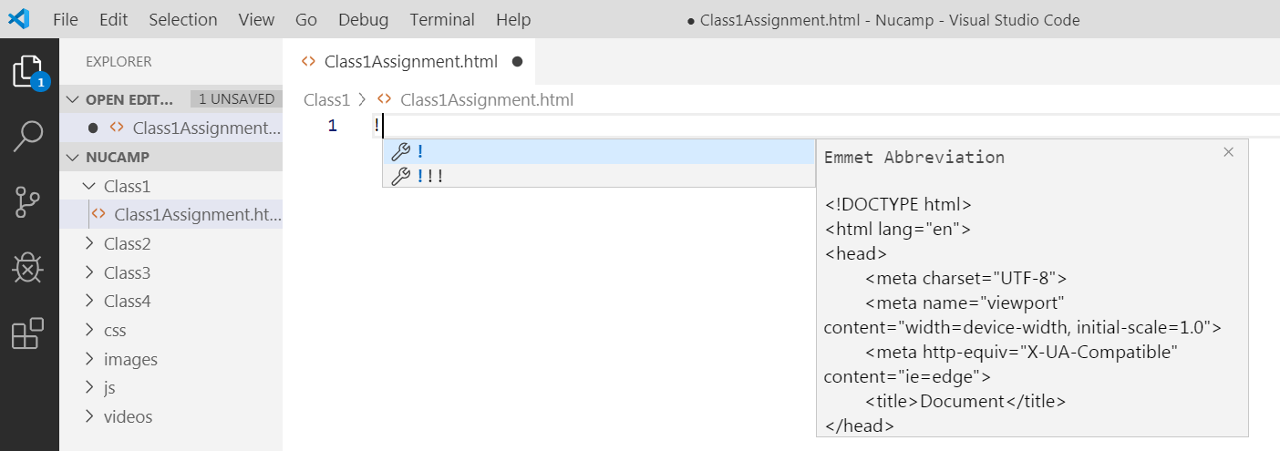
6b) Select the first level of “Emmet Abbreviation” and you should see a basic HTML page
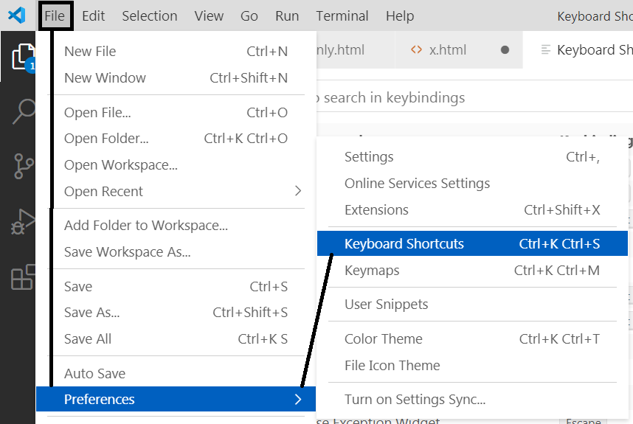
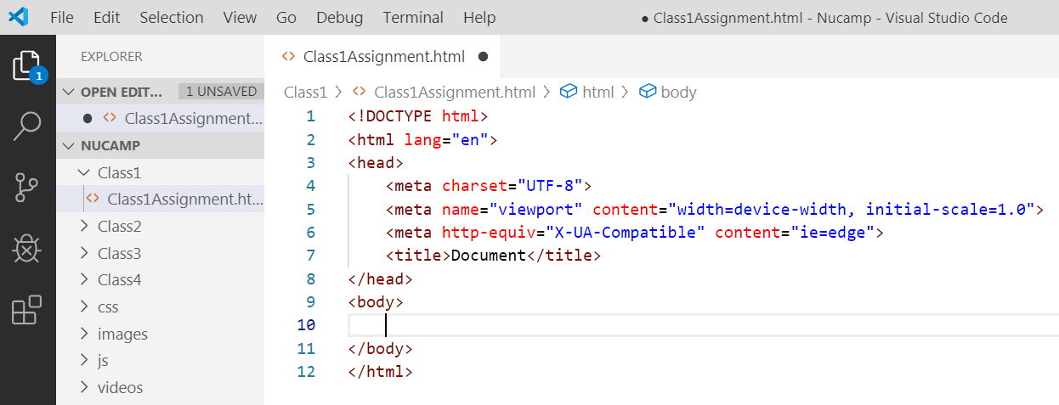
7) Do a quick save (Ctrl + s), and now let’s talk code… (Auto Format: Alt + Shift + f )… See All Shortcuts: https://vscode-shortcuts.com
HTML is a markup language… That’s how it gets its name: HyperText Markup Language… (Kind of like how a publisher marks up a manuscript before sending it to the printer: What goes where, what kind of font, how large the type should be, images, color…and so on…)

You can build an entire web site using only HTML (in fact, that’s the way we used to do it… way back when things were just starting up on the internet).

There are a lot of HTML tags, but you really don’t have to know them all… (Just know how they work and how to find them).

However, there are several tags (elements) that you need to know. (Rem: all tags start and end with “angle brackets”: “<” and “>”)

First, you need to know the structure/syntax of HTML tags
- HTML tags generally have both a start and end tag: (i.e., <p> </p>) , but not all do: <img src="x.jpg"/> (void, non-closing self-closing, binary)
- Everything between a start and end tag, including both the start and end tag, are considered an Element.
<div id="Home">
Here is a <div> element with an <h1 >and a <p> element(s) embedded in it...
The <h1> element has “Home” embedded within it…
The <p> element has “Lorem ipsum” embedded within it…
<h1>Home</h1>
<p>Lorem ipsum</p>
</div>
- HTML is not case-sensitive, but it should be… keep to one case - to be sure that CSS, and JS don’t get confused (lower case is best).
- HTML tags have attributes, which tell the tags how to act. Many attributes are deprecated, and superseded by CSS,
but Some attributes are important: Such as “src” for images, “action” and “method” for forms, and “href” for anchors (links), to name a few.
Side Note:
The importance of proper indenting of code
Code can get very messy… And although you can write an HTML page without any code indentation at all… it will be almost impossible to read. It is best practice to start clearly indenting your code as you write it… Use the auto-complete tools in VSCode as well.

(Auto Format: Alt + Shift + f )

Fun Facts…Domains (web sites use a domain to represent an IP) [and you have one: Localhost (127.0.0.1)] use Live Server
(For now, we will work with our Localhost…but know how to work with a domain…).
Registering a Domain
Remember: Domain name (google.com) is the registered address of your website and maps to an IP address (172.217.6.206) on the host server. (Shared IP’s vs. Dedicated IP’s)
Method 1: With a Hosting Service
Method 2: Without a Hosting Service
https://www.wikihow.com/Register-a-Domain-Name

Ok… back to HTML…

Some Tags (Elements) you need to know:
Tags (AKA: Elements) – As noted above, many Tags (by classification) are also Elements (these terms are often interchanged)…
- The <!DOCTYPE html> tag: This tells the browser what DTD to use (There is a Document Type Definition DTD that the browser uses – W3C)
- The <html> tag: This tells the browser you are using HTML as opposed to XML or XHTML…. You can add an attribute like language.
- The <head> tag: This element holds non-visible (meta data) information - such as your page title and meta data
- The <title>My Home Page</title>tag: Used for improving user experience and SEO. Also what the user sees in the browser tab…
- The <link> tag: Used to link to external style sheets. Need an href, and rel <link rel="stylesheet" type="text/css" href="theme.css">
The <link> tag is also used for Favicons (size 16×16, 32×32 / ico, gif, jpg): <link rel="icon" href="../images/ben.ico" type="image/x-icon">
- The <meta> tag: Various meta tag attributes tell the browser key information such as the character set, or a page's dimensions and scaling, but are also used for SEO, and even redirection (Don’t need to memorize these… just know what they do, and how to find them)
  - <meta charset="UTF-8"> In the beginning (1963), there was only ASCII (128 char then 256). UTF-8 Unicode Transformation Format came 1992 1m+.
  - <meta name="viewport" content="width=device-width, initial-scale=1.0"> viewport adjusts with the device
  - Below are other useful Meta tags
SEO
Search Engine Optimization
is the process of improving the quality and quantity of website traffic to a website or a web page from search engines.
  - <meta name="description" content="Free Web tutorials"> Search Engine Optimization (SEO)
  - <meta name="keywords" content="HTML,CSS,XML,JavaScript"> SEO
  - <meta http-equiv="refresh" content="5;URL=http://google.com"> 5 second wait… then off to google
  - <meta http-equiv="Cache-Control" content="no-cache" /> no caching of page
  - There are many more meta tags… see Head and Body elements.html or W3Schools
- The <body> Element: The head holds the visible information that is seen by the user
- The <a href="http://drpage.net/nucamp/index.html">Dan's Nucamp Page</a> Anchor tag: REM: the href attribute is required (target)
- The <img src="MyLife.jpg" height="100" alt="banner" > Image tag: REM: the src attribute is required. The alt attribute is important.
- The <form action="results.html" method="get">Form tag: REM: the action and method attributes are required – used for passing user information to the server (middle tier and/or backend). Multiple Child tags. Discussed in detail next week
<input type=”text or number or checkbox or radio or file or submit…”> , <textarea>, <select> &<option> , <button> and more…
- The <p> Lorem ipsum </p> Paragraph element: block tag for large amounts of text
HTML Element Reference - By Category
w3schools.com
https://www.w3schools.com/tags/ref_byfunc.asp

<div> Defines a section in a document
<span> Defines a section in a document
<header> Defines a header for a document or section
<footer> Defines a footer for a document or section
<main> Specifies the main content of a document
<section> Defines a section in a document
<article> Defines an article
<p> Defines a paragraph
- The <h1> Lorem ipsum </h1> Heading elements: h1 – h6 block tags used for heading text
- The <div> Lorem ipsum </div> Division tag: block element used for HTML structure
- The <span> Lorem ipsum </span> Span tag: non-block element used for formatting
- The <ul> unordered list, and the <ol> Ordered list tags: bullet point lists and numbered lists
  - The child <li> List Item tag: used with the <ul>, and the <ol> tags: to show each list item
- The <table> with rows <tr> and cells <td> (discussed below)
- Two more tags
- The <style></style>tag: used for CSS
- The <script></script>tag: used for JavaScript
- There are others that you may want to look at… see Head and Body elements.html or W3Schools
- There are special characters that are used in HTML for things like copyright, and math symbols - https://www.w3schools.com/html/html_symbols.asp
- The <!-- comment --> tag is used for comments
Attributes
All HTML Tags allow attributes. Attributes modify the default behavior of an element. Order of attributes does not matter.
Attributes are generally all name-value pairs (although a few are binary and just default to the true value).
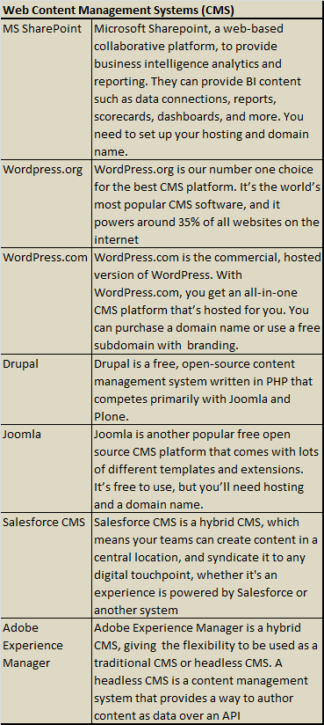
There are lots of attributes, many are deprecated, or rarely used, but here are a few you should know…
Identifiers
id | id="myIDValue" | adds a unique ID for an element
class | class="myClassValue" | creates a relation between elements and stylesheets
name | name="myNameValue" | Specifies the name of the element (forms and iFrames)
CSS
style | style="background-color: black; " | provides inline styling for an element
Hyperlinks
href | href="https://www.nucamp.co/" | adds a URL destination for a link, creating a hyperlink
Images
src | src="image.png" | defines an external source for an element
width | width="100" | changes the element's dimensions
height | height="100" | changes the element's dimensions
alt | alt="Image name" | text displayed if element (image) cannot be loaded
Meta
charset | charset="UTF-8" | Describes metadata
content | content="My Web Site" | Describes metadata
Deprecated
bgcolor | bgcolor="#000000" | Specifies the background color of an element
color | color="#ffffff" | Specifies the text color
Forms
checked | checked (boolean) | Specifies that an <input> element is pre-selected
for | for="male" | Specifies which form element a label is bound to
required | required (boolean) | Specifies that an <input> element is required
value | value="click me" | Specifies the value of the element
Scripting
on… trigger | onload="myScript()" onclick="myScript()" etc. | Script to be run

Wow… Time to build a Web Page – Week 1 Class Assignment
First we need to do our Week 1 - Nucamp In-Class Assignment - Profile Basic Web Page Instructions. Link to instructions
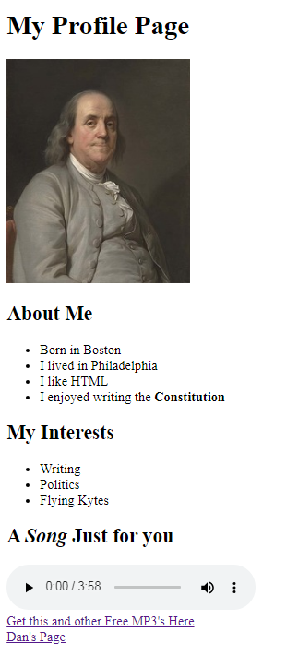
A few HTML Tags that may be useful (but are mostly deprecated) for this assignment…
The <b></b> tag specifies bold text.
The <blockquote><blockquote> tag - Browsers usually indent
The <br/> tag inserts a single line break
The <center></center> tag was used to center-align text
The <em></em> and <i></i> tag is used to define (italic) emphasized text.
The <font></font> tag was used to specify the font face, size, and color of text.
The <hr/> tag defines a thematic break (as a horizontal rule)
The <strong></strong> tag is used to define important or bold text
The <sub></sub> tag defines _{subscript} text.
The <sup></sup> tag defines ^{superscript} text

Special Characters
© | &copy; | Copyright
® | &reg; | Registered Sign
™ | &trade; | Trademark
space | &nbsp; | Non-breaking Space - HTML does not recognize more than one space
< > | &lt; &gt; | Less Than and Greater Than signs (for math…)

There are a whole lot more … Search for “html special characters”… or go here
https://html-css-js.com/html/character-codes/html4/

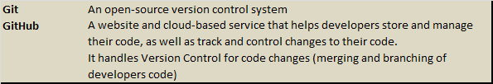

Save Your File!!! (Ctrl + s). You will need to turn it in (submit it) by Monday COB.

Now for some fun with just HTML
Building a simple one-page Web Site (Note: This is not required, but you might enjoy doing the code…)

Aside from just building a basic HTML page in our first “Week 1 Workshop Assignment”, you may also want to develop (design) a single-page, four section, website using a simple image-link menu and an iframe. Below is the basic design (structure) of many web pages. You can build a page with pure HTML… (Yes… Just for today… we will only use HTML… Normally we would use HTML, + CSS, and JavaScript).

(1) Header
(2) Menu: Home About Assignment Contact
(3) Content container
(Actually contains 4 parts)

Home
About
Week 1 Assignment
Contact

(4) Footer
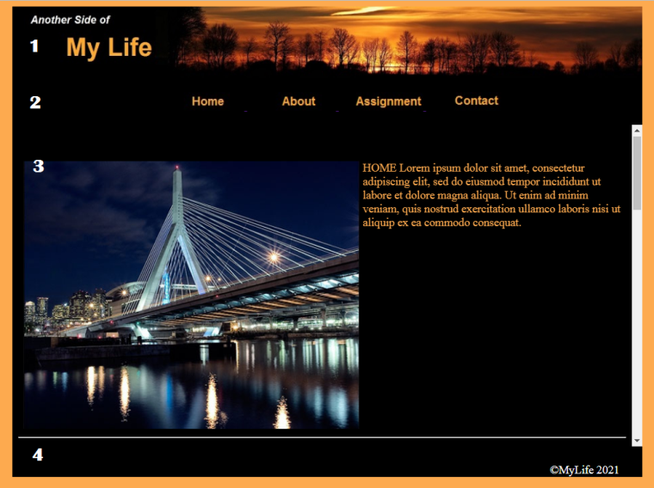
Create a new HTML Page in VSCode (name it index.html, or anything you like… but no spaces in the name)
Things you need:
- A Header Image: http://drpage.net/nucamp/images/MyLife.jpg (or use your own image – search on panoramic views)

- Four button images (or make your own)
- Lorem ipsum text:
Notes
- The use of the body tag attribute for color. bgcolor="#fdaa4f"
- The height attribute for the image tag
- The use of the Font tag for size and color of the h1 tag content
- The align attribute for the h3 tag
Lorem ipsum dolor sit amet, consectetur adipisci elit, sed eiusmod tempor incidunt ut labore et dolore magna aliqua. Ut enim ad minim veniam, quis nostrum exercitationem ullam corporis suscipit laboriosam, nisi ut aliquid ex ea commodi consequatur. Quis aute iure reprehenderit in voluptate velit esse cillum dolore eu fugiat nulla pariatur. Excepteur sint obcaecat cupiditat non proident, sunt in culpa qui officia deserunt mollit anim id est laborum.

Cheap Tricks: A web page using only HTML with tables.
This is how it was done in the old days… but it is worth knowing (LOL)

But Don’t Do This In Front Of Your Boss!
Open a new HTML file called: index.html  To create the page, select the first level of “Emmet Abbreviation” (Shift + !).  In the head you can add a favicon if you like.  Also add an appropriate title…  In the body:  Set the body background “bgcolor” attribute to a variation of SandyBrown: #fdaa4f  Build the following parts (elements) of the page:  <header></header> We will add an image in this element.  <menu></menu> We will add an image-links here  <main></main> This element is for our content.  <footer></footer>We will add a © copyright. | <!DOCTYPE html>  <html lang="en">  <head>  <meta charset="UTF-8">  <meta name="viewport" content="width=device-width, initial-scale=1.0">  <link rel="icon" href="http://www.drpage.net/nucamp/images/dp.gif" type="image/gif">  <title>My Life</title>  </head>  <body bgcolor="#fdaa4f">  <header></header>  <menu></menu>  <main></main>  <footer></footer>  </body>  </html>
Go ahead and add an image in the header element.  A word on Absolute Vs. Relative addresses:  To get from your html page to your images folder you need to navigate up to your root directory (unless your images folder is in your class1 folder). To navigate up one level to your root folder, in the src attribute type  “ ../ ”, or inside your Class folder type “ ./ ”  In VS Code auto complete will help you find the folder and file you are looking for…  An Absolute address will contain the entire URL:  http://www.drpage.net/nucamp/images/MyLife.jpg  Both work, but get familiar with using relative paths.  In the footer, add a © copyright. See the notes above for special characters. &copy;  Next we will work on the menu & main elements… | <!DOCTYPE html>  <html lang="en">  <head>  <meta charset="UTF-8">  <meta name="viewport" content="width=device-width, initial-scale=1.0">  <link rel="icon" href="http://www.drpage.net/nucamp/images/dp.gif" type="image/gif">  <title>MyLife</title>  </head>  <body bgcolor="#fdaa4f">  <header>  <img src="../images/MyLife.jpg" id="top" width="100%" alt="banner">  </header>  <menu></menu> <!-- do this next -->  <main></main> <!-- do this next -->  <footer align="right" >  <font color="#ffffff">  <br>&copy;MyLife 2021 &nbsp; &nbsp; &nbsp; &nbsp;  </font>  </footer>  </body>  </html>

The menu & main elements are tied together by image-links which interact with an iFrame.  The Inline Frame element <iframe> represents external content embedded in another HTML page. Created by Microsoft in 1997 – incorporated by all browsers by 2000.  iframe Attributes:  - The src attribute defines the URL of the page to embed  - The height and width attributes to specify the size of the iframe, specified in pixels or % .  - The name attribute is used in the target attribute of the <a> elements  - The scrolling and frameBorder attributes are optional for enhanced user experience.  Alternatives to the iframe are: embed and object tags  <embed type="text/html" src="content1.html"width="100%" height="500" name="content"> | <menu align="center">  <a href="content1.html#home" target="content">  <img src="../images/Home.jpg" alt="Home">  </a> &nbsp; &nbsp; &nbsp;  <a href="content1.html#about" target="content">  <img src="../images/About.jpg" alt="About">  </a> &nbsp; &nbsp; &nbsp;  <a href="content1.html#assignment" target="content">  <img src="../images/Assignment.jpg" alt="Assignment">  </a> &nbsp; &nbsp; &nbsp;  <a href="content1.html#contact" target="content">  <img src="../images/Contact.jpg" alt="Contact">  </a>  </menu>  <main>  <iframe src="content1.html" width="100%" height="450"  scrolling="yes" name="content" frameBorder="0" >  </iframe>  </main>
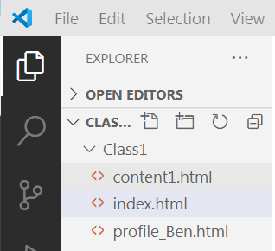
The inline frame (iFrame) is used to embed an HTML document within another HTML document.

The source document we will embed is content1.html
The image-links will use this file as their href=”” attribute value.

Notice that iFrames also make use of Bookmarks to jump to a specific location in the embedded file.
href="content1.html#home"

Take a look at the content1.html file below. The content1.html file is separate file from the index.html file.
Create a new HTML file named content1.html in the same folder as your index.html file.
<base> Specify a default URL and default target for all links on a page:
<head>
<base href="http://drpage.net/nucamp/" target="_blank">
</head>
<body>
<img src="images/home.gif" width="24" height="39">
<a href="Class1/MyLife.html">HTML base Tag</a>
</body>

A note on the Target attribute: the target attribute specifies where to open the linked document.
Primarily used with <a> anchor tags and <form> tags (but also with <area> and <base> tags)
_blank Opens the linked document in a new window or tab
_self (default) Opens the linked document in the same frame as it was clicked
_parent Opens the linked document in the parent frame – not used much (old Frame days)
_top Opens the linked document in the full body of the window – not used much
iFrameName Opens the linked document in the named iframe

Give each section tag an id attribute that correlates to the bookmark in the anchor tag,  Notice the use of tables to structure the image and text content of each section  The Table element  A table is an element made up of rows and columns.  We will build our table manually, but you could also use a table generator…  (http://www.drpage.net/nucamp/CodeGenerator_WYSIWYG.html)  NOTE: Tables should be used for tabular data — this is what they are designed for. But in the past, a lot of people used tables to lay out web pages, (e.g. one row to contain the header, one row to contain the content columns, one row to contain the footer, etc.). And you still see it occasionally…  The Table <table></table> tag is the parent element.  The first child of a table is the Row <tr></tr> (aka: table row)  The Row <tr> has its own child – The Cell (aka: table data) <td></td>  You can have as many rows and cells as you like…  There is also a Table Heading row. Mostly used for first table row. <th></th> (we won’t use it)  Table Attributes:  Copy the code and add it to your content1.html file | <!—The content is embedded - it does not need head or body elements -->  <section id="home">  <h2>Home</h2>  <table>  <tr>  <td>  <font color="#fdaa4f">  <img src="../images/bridge.jpg" alt="bridge" height="375" align="left">  HOME Lorem ipsum dolor sit amet, consectetur adipiscing elit, sed do eiusmod tempor incididunt ut labore et dolore magna aliqua. Ut enim ad minim veniam, quis nostrud exercitation ullamco laboris nisi ut aliquip ex ea commodo consequat.  </font>  </td>  </tr>  </table>  <hr>  </section>  <section id="about">  <h2>About</h2>  <table>  <tr>  <td>  <font color="#fdaa4f">  <img src="../images/tree.jpg" alt="Tree" height="375" align="right">  About Lorem ipsum dolor sit amet, consectetur adipiscing elit, sed do eiusmod tempor incididunt ut labore et dolore magna aliqua. Ut enim ad minim veniam, quis nostrud exercitation ullamco laboris nisi ut aliquip ex ea commodo consequat. Duis aute irure dolor in reprehenderit in voluptate velit esse cillum dolore eu fugiat nulla pariatur.  </font>  </td>  </tr>  </table>  <hr>  </section>  <section id="assignment">  <h2>Assignment</h2>  <table align="center"><tr><td >  <iframe src="http://drpage.net/nucamp/Class1/profile_Ben.html" width="500" height="400" scrolling="yes" frameborder="0"></iframe>  </td></tr></table>  <hr>  </section>  <section id="contact">  <h2>Contact</h2>  <table>  <tr>  <td>  <img src="../images/joanne.jpg" alt="Joanne" height="375">  </td>  <td align="center" valign="top" width="25%">  <font color="#fdaa4f">  12707 Northeast 30th Street <br>  Bellevue, WA 98005<br>  United States  </font>  </td>  </tr>  </table>  </section>
  Attribute | Description | Syntax Example
  Border | used to specify border around the table & cells | border="2"
  Cell Padding | specify amount of spacing between border and cell content. | cellpadding="5"
  Cell Spacing | specify amount of spacing between two adjacent cells. | cellspacing="3"
  Width | used to set the width of the table. | width="80%"
  align | used to set the alignment of table horizontally. | align="centre"
  bgcolor | used to set the background color of the table. | bgcolor="blue"
  background | used to set image in the table background. | background="image.jpg"

Putting it all together…

If you run the code as it is it will work, but depending on screen resolution, the page may get a little jumpy, an is not well aligned.  So, an old trick to center an purely HTML page is to add a table around all of the body content..  <body bgcolor="#fdaa4f">  <table align="center" bgcolor="#000000" cellspacing="0" cellpadding="0"><tr><td>  <header>  ... all other code ...  </footer>  </td></tr></table>  </body> | <!DOCTYPE html>  <html lang="en">  <head>  <meta charset="UTF-8">  <meta name="viewport" content="width=device-width, initial-scale=1.0">  <link rel="icon" href="http://www.drpage.net/nucamp/images/dp.gif" type="image/gif">  <title>MyLife</title>  </head>  <body bgcolor="#fdaa4f">  <table align="center" bgcolor="#000000" cellspacing="0" cellpadding="0"><tr><td>  <header>  <img src="../images/MyLife.jpg" id="top" width="100%" alt="banner">  </header>  <menu align="center">  <a href="content1.html#home" target="content">  <img src="../images/Home.jpg" alt="Home">  </a> &nbsp; &nbsp; &nbsp;  <a href="content1.html#about" target="content">  <img src="../images/About.jpg" alt="About">  </a> &nbsp; &nbsp; &nbsp;  <a href="content1.html#assignment" target="content">  <img src="../images/Assignment.jpg" alt="Assignment">  </a> &nbsp; &nbsp; &nbsp;  <a href="content1.html#contact" target="content">  <img src="../images/Contact.jpg" alt="Contact">  </a>  </menu>  <main>  <iframe src="content1.html" width="100%" height="450"  scrolling="yes" name="content" frameBorder="0" >  </iframe>  </main>  <footer align="right" >  <font color="#ffffff">  <br>&copy;MyLife 2021 &nbsp; &nbsp; &nbsp; &nbsp;  </font>  </footer>  </td></tr></table>  </body>  </html>

Left Menu
Of course you could do the whole thing with a left side menu too…
This time set the page up with only header, main, and footer elements | <!DOCTYPE html>  <html lang="en">  <head>  <meta charset="UTF-8">  <meta name="viewport" content="width=device-width, initial-scale=1.0">  <link rel="icon" href="../images/dp.gif" type="image/gif">  <title>My Life - HTML Only</title>  </head>  <body bgcolor="#fdaa4f"><!-- rgb( 253, 170, 79) is not supported -->  <header>  <img src="../images/MyLife.jpg" id="top" width="100%" alt="banner">  </header>  <main></main> <!-- do this last -->  <footer align="right" >  <font color="#ffffff">  <br>&copy;MyLife 2021 &nbsp; &nbsp; &nbsp; &nbsp;  </font>  </footer>  </body>  </html>
Then for the main element, add a table with one row and two cells…  Use the same iFrame with the source of content1.html | <main>  <table border="0" width="100%" bgcolor="#000000">  <tr>  <td width="20%" valign="top" align="center">  <h1>Menu</h1>  </td>  <td width="80%">  <iframe src="content1.html" width="100%" height="500"  scrolling="yes" name="content" frameBorder="0" >  </td>  </tr>  </table>  </main>
For the menu,  In the first table cell, set the cell width to 20%,  With vertical alignment to top, and horizontal alignment to center…  Then just replace the &nbsp; code with <br> break tags <br/>  Now it should work the same… | <main>  <table border="0" width="100%" bgcolor="#000000">  <tr>  <td width="20%" valign="top" align="center">  <h1>Menu</h1>  <a href="content1.html#home" target="content">  <img src="../images/Home.jpg" alt="Home">  </a><br>  <a href="content1.html#about" target="content">  <img src="../images/About.jpg" alt="About">  </a><br>  <a href="content1.html#assignment" target="content">  <img src="../images/Assignment.jpg" alt="Assignment">  </a><br>  <a href="content1.html#contact" target="content">  <img src="../images/Contact.jpg" alt="Contact">  </a>  </td>  <td width="80%">  <iframe src="content1.html" width="100%" height="500"  scrolling="yes" name="content" frameBorder="0" >  </iframe>  </td>  </tr>  </table>  </main>

Completed Code index.html

<!DOCTYPE html>
<html lang="en">
<head>
<meta charset="UTF-8">
<meta name="viewport" content="width=device-width, initial-scale=1.0">
<link rel="icon" href="http://www.drpage.net/nucamp/images/dp.gif" type="image/gif">
<title>MyLife</title>
</head>
<body bgcolor="#fdaa4f">
<table align="center" bgcolor="#000000" cellspacing="0" cellpadding="0"><tr><td>
<header>
<img src="../images/MyLife.jpg" id="top" width="100%" alt="banner">
</header>
<menu align="center">
<a href="content1.html#home" target="content">
<img src="../images/Home.jpg" alt="Home">
</a> &nbsp; &nbsp; &nbsp;
<a href="content1.html#about" target="content">
<img src="../images/About.jpg" alt="About">
</a> &nbsp; &nbsp; &nbsp;
<a href="content1.html#assignment" target="content">
<img src="../images/Assignment.jpg" alt="Assignment">
</a> &nbsp; &nbsp; &nbsp;
<a href="content1.html#contact" target="content">
<img src="../images/Contact.jpg" alt="Contact">
</a>
</menu>
<main>
<iframe src="content1.html" width="100%" height="450"
scrolling="yes" name="content" frameBorder="0" >
</iframe>
</main>
<footer align="right" >
<font color="#ffffff">
<br>&copy;MyLife 2021 &nbsp; &nbsp; &nbsp; &nbsp;
</font>
</footer>
</td></tr></table>
</body>
</html>

Completed Code content1.html

<!-- content is embeded - it does not need head or body elements -->
<section id="home">
<h2>Home</h2>
<table>
<tr>
<td>
<font color="#fdaa4f">
<img src="../images/bridge.jpg" alt="bridge" height="375" align="left" hspace="5">
HOME Lorem ipsum dolor sit amet, consectetur adipiscing elit, sed do eiusmod tempor incididunt ut labore et dolore magna aliqua. Ut enim ad minim veniam, quis nostrud exercitation ullamco laboris nisi ut aliquip ex ea commodo consequat.
</font>
</td>
</tr>
</table>
<hr>
</section>
<section id="about">
<h2>About</h2>
<table>
<tr>
<td>
<font color="#fdaa4f">
<img src="../images/tree.jpg" alt="Tree" height="375" align="right">

About Lorem ipsum dolor sit amet, consectetur adipiscing elit, sed do eiusmod tempor incididunt ut labore et dolore magna aliqua. Ut enim ad minim veniam, quis nostrud exercitation ullamco laboris nisi ut aliquip ex ea commodo consequat. Duis aute irure dolor in reprehenderit in voluptate velit esse cillum dolore eu fugiat nulla pariatur.
</font>
</td>
</tr>
</table>
<hr>
</section>
<section id="assignment">
<h2>Assignment</h2>
<table align="center"><tr><td >
<iframe src="http://drpage.net/nucamp/Class1/profile_Ben.html" width="500" height="400" scrolling="yes" frameborder="0"></iframe>
</td></tr></table>
<hr>
</section>
<section id="contact">
<h2>Contact</h2>
<table>
<tr>
<td>
<img src="../images/joanne.jpg" alt="Joanne" height="375"><br><br><br><br><br><br>
</td>
<td align="center" valign="top" width="30%">
<font color="#fdaa4f">
12707 Northeast 30th Street <br>
Bellevue, WA 98005<br>
United States
</font>
</td>
</tr>
</table>
</section>

Completed Code index2.html

<!DOCTYPE html>
<html lang="en">
<head>
<meta charset="UTF-8">
<meta name="viewport" content="width=device-width, initial-scale=1.0">
<link rel="icon" href="http://www.drpage.net/nucamp/images/dp.gif" type="image/gif">
<title>MyLife</title>
</head>
<body bgcolor="#fdaa4f">
<table align="center" bgcolor="#000000" cellspacing="0" cellpadding="0"><tr><td>
<header>
<img src="../images/MyLife.jpg" id="top" width="100%" alt="banner">
</header>
<menu align="center">

</menu>
<main>
<table border="0" width="100%" bgcolor="#000000">
<tr>
<td width="20%" valign="top" align="center">
<h1>Menu</h1>
<a href="content1.html#home" target="content">
<img src="../images/Home.jpg" alt="Home">
</a><br>
<a href="content1.html#about" target="content">
<img src="../images/About.jpg" alt="About">
</a><br>
<a href="content1.html#assignment" target="content">
<img src="../images/Assignment.jpg" alt="Assignment">
</a><br>
<a href="content1.html#contact" target="content">
<img src="../images/Contact.jpg" alt="Contact">
</a>
</td>
<td width="80%">
<iframe src="content1.html" width="100%" height="500"
scrolling="yes" name="content" frameBorder="0" ></iframe>
</td>
</tr>
</table>
</main>

<footer align="right" >
<font color="#ffffff">
<br>&copy;MyLife 2021 &nbsp; &nbsp; &nbsp; &nbsp;
</font>
</footer>
</td></tr></table>
</body>
</html>

Completed Code profile.html

<!DOCTYPE html>
<html lang="en">

<head>
<meta charset="UTF-8">
<meta name="viewport" content="width=device-width, initial-scale=1.0">
<title>Prifile Ben</title>
</head>

<body bgcolor="#cccccc">
<h1>My Profile Page</h1>
<section>
<img src="../images/Ben.jpg" alt="Ben" height="200" />
<h2>About Me</h2>
<ul>
<li>Born in Boston</li>
<li>Live in Phily</li>
<li>Like HTML</li>
<li>Helped write the Constitution</li>
</ul>
</section>
<hr>
<section>
<h2>My Interests</h2>
<ol>
<li><i>Writing</i></li>
<li>Politics</li>
<li>Flying <b>Kites</b></li>
</ol>
</section>
<hr>
<section>
<h2>A song for you</h2>
<audio src="../media/Haydn_Adagio.mp3" controls>
<sub> Get a better browser...</sub>
</audio>
<audio controls>
<source src="../media/Haydn_Adagio.mp3" />
<source src="../media/Tchaikovsky_Rococo_Var_orch.mp3" />
<sub> Get a better browser...</sub>
</audio>
</section>
<section>
<h2>Social Media</h2>
<a href="https://www.facebook.com/nucamp.co/" target="_blank">
<img src="../images/FB.jpg" alt="Facebook">
</a><br>
<iframe width="560" height="315" src="https://www.youtube.com/embed/6iuctWusJ7w" title="YouTube video player" frameborder="0" allow="accelerometer; autoplay; clipboard-write; encrypted-media; gyroscope; picture-in-picture" allowfullscreen></iframe>
</section>
</body>
</html>

