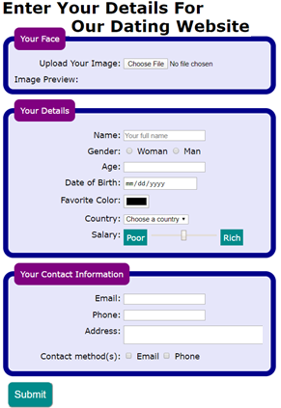
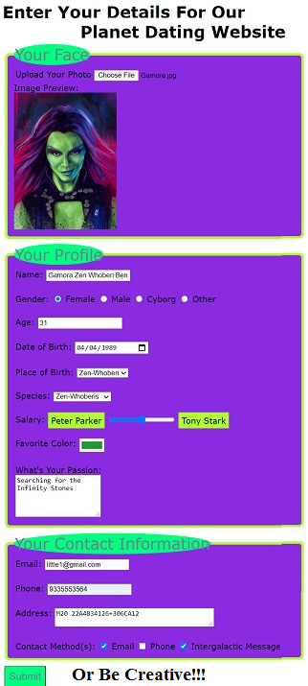
In this class, first we will do the assignment… then if we have time we can have some fun with CSS and menus.

Week 2 Workshop Assignment
The Premise
A startup company wishes to build a website for their online dating business. They have employed a designer who has produced the following design using graphics software. The software used by the designer only produces an image and does not produce HTML.
The company has now contracted you to implement the design i.e. build the web page. This includes a working form component. The company thinks the designer has done a great job and wants you to implement the design without altering the style. (Not in this class… Feel free to be creative!)
Technical Overview
From a technical point of view, the webpage is constructed using HTML and CSS. Most of the HTML content are form elements. Some JavaScript will be required, but you will not have to write it, only follow the instructions to include it where needed.
Interactive Features
The company requires you to have two interactive features in the web page.
- When the mouse is moved over any form control or its associated label, the label text will turn blue.
- When the mouse moves off it, it will return to its normal color. This will be accomplished using CSS.
Immediately after the user selects the image of his/her face, the image is to be shown in the web page. A small piece of JavaScript will be provided for you to use for this. However, you are not expected to understand the JavaScript code at this stage in the course and should not create any other JavaScript for this assignment.
But first, let’s discuss Forms…
Forms are the way you can allow users to interact with your web application (between the client and server).
A form allows the user to input information on a page and then send it to a target location (such as a middle tier program or backend database).
The <form></form> element is the parent container for many child elements and input types that get passed.
The form tag has two required attributes (and one more if you are passing encrypted files), (and yet another one if you are targeting iFrames).
<form action="where_to_send_it.html" method="how_to_send_it.html" enctype="for_file_encoding" target=" _self"></form>

The action is the target location. Without an action the form just passes the data back to the same page (sometimes referred to as a Postback).
The method lets you determine how the data travels to the target
GET is less secure compared to POST because data sent is part of the URL. Never use GET when sending passwords or other sensitive information! Get also has a maximum URL length is 2048 characters.
- method="get" via the URL querysting
- method="post" stored in the request body of the HTTP request
The enctype allows you to modify encoding. By default a form is sent to the target with all characters encoded (spaces are converted to "+" symbols…).
If you want to send a file, such as an image, encoding will ruin the file, so you set the enctype=" multipart/form-data" . This only works with Post.
enctype =
application/x-www-form-urlencoded
Default. All characters are encoded before sent (spaces are converted to "+" symbols, and special characters are converted to ASCII HEX values)
multipart/form-data
No characters are encoded. This value is required when you are using forms that have a file upload control
text/plain
Spaces are converted to "+" symbols, but no special characters are encoded
You can use the target attribute if you want the response to open in a new window or an iFrame.
There are several targets
_blank The response is displayed in a new window or tab
_self The response is displayed in the same frame (this is default)
_parent The response is displayed in the parent frame
_top The response is displayed in the full body of the window
framename The response is displayed in a named iframe

Form Elements
We will go over all of the following in the class 2 Workshop (covered below…)
<form action="#">
<fieldset>
<legend>fieldset legend</legend>
<label for="mylife">label for input</label>
<input type="radio" id="mylife">
</fieldset>
</form>
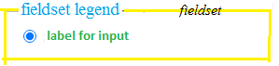
Tags: <input type=”…” > , <fieldset> , <label> , <select> , <textarea> , <option>
We will discuss each one individually…
But… a quick word about <fieldset> (groupings) vs. <legend> (caption to a fieldset) vs. (<label for="some_input">)
<fieldset> Sets the block (outline/border)
<legend> describes the fieldset block
<label> is for the form element id description
Back to our Week 2 Assighment…

Assignment Tasks
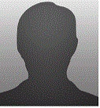
There are 3 tasks in this assessment.
For Task 1: You will use HTML to create the webpage structure and add content, without any CSS.
For Task 2: Apply visual styles to the webpage using CSS.
For Task 3: Add the interactive features to the webpage.
Each task has been further separated into smaller parts to help organize your approach.
Detailed requirements and instructions are given below.

TASK 1: Use HTML to create the webpage structure and add content
Part 1: Set up the document  - Create a basic, valid HTML5 document as you learned to do in Week 1.  Be sure to set the DOCTYPE and an appropriate title and meta charset. | <!DOCTYPE html>  <html lang="en">  <head>  <meta charset="UTF-8">  <meta name="viewport"  content="width=device-width, initial-scale=1.0">  <title>Date Me</title>  </head>  <body>  <h1>Enter Your Details For Our Dating Website</h1>  <!-- <form action="results.html" method="get"> -->  <form action="https://learn.nucamp.co/show_everything.php"  method="post" enctype="multipart/form-data">  <!-- All of the form child elements go here – see Part 3 -->  </form>  </body>  </html>

Part 2: Set up the form element
- In the body of your HTML document, create a level 1 heading with the text Enter Your Details For Our Dating Website.
- Beneath this, create a form element with three attributes:
  - Set the action attribute to: (the action attribute is like src or href) "https://learn.nucamp.co/show_everything.php".
  - Set the method attribute to "post".
  - Set the enctype attribute to "multipart/form-data".
(no characters are encoded… By default all characters are encoded)
(Note: there is a “get” method form tag that goes to a page called resultsl.html - We will experiment with this form later, so it will remain commented out for the time being)

Part 3: First Fieldset - Your Face  - Create a fieldset inside the form element. All the following elements in this part will go inside this fieldset. (Block Element used to group related elements in a form)  - Add a legend with the text Your Face. (Block Element defines a caption for the fieldset)  - Below the legend, add a div element. Inside the div, add the following elements: (non-Block Element: The label tag defines a label for form elements / 508 compl)  - label attribute: for="avatar" and text: "Upload Your Image: "  - input with attributes: type="file", id="avatar", name="avatar", required  - After the div element, add the text "Image Preview: " followed by an img element with these attributes: id="preview", width="500".  (Note: You can download a NoFace.jpg image here: http://www.drpage.net/nucamp/images/NoFace.jpg) | <!-- First Fieldset -->  <fieldset>  <legend>Your Face</legend>  <div>  <label for="avatar">Upload Your Image:</label>  <input type="file" id="avatar" name="avatar" required />  </div>  Image Preview:  <img id="preview" src="images/NoFace.jpg" width="200" />  </fieldset>
Part 4: Second Fieldset - Your Details  - Create a second fieldset inside the form element. All the following elements in this part will go inside this fieldset.  - Add a legend with the text Your Details.  - Below the legend, add a div element. Inside the div, add the following elements:  - label with attribute: for="name" and text: "Name: "  - input with attributes: type= "text", id="name", name="name",  placeholder="Your full name", required  - Add a second div below the previous one. Inside this div, add the following elements:  - input with attributes: type="radio", id="woman", name=“gender”,  value="woman", required  - label with attribute: for="woman" and text: "Woman"  - input with attributes: type="radio", id="man", name=“gender”, value="man"  - label with attribute: for="man" and text: "Man"  - Add a third div below the previous one. Inside this div, add the following elements:  - label with attribute: for="age" and text "Age: "  - input with attributes: type="number", id=”age”, name=“age”  - Add a fourth div below the previous one. Inside this div, add the following elements:  - label with attribute: for="dob" and text: "Date of Birth: "  - input with attributes: type="date", id=”dob”, name=“dob”  - Add a fifth div below the previous one. Inside this div, add the following:  - label with attribute: for="color" and text "Favorite Color: "  - input with attributes: type="color", id=”color”, name=“color”  - Add a sixth div below the previous one. Inside this div, add the following elements:  - label with attribute: for="country" and text: "Country: "  - select with attributes: id="country", name="country" and the following options:  - option with text "Choose a country"  - option with attribute: value="brazil" and text: "Brazil"  - option with attribute: value="france" and text: "France"  - option with attribute: value="japan" and text: "Japan"  - option with attribute: value="libya" and text: "Libya"  - option with attribute: value="usa" and text: "U.S.A."  - Add a seventh div below the previous one. Inside this div, add the following elements:  - label with attribute: for="salary" and text: "Salary: "  - span with attribute: class="range-caption" and text "Poor"  - input with attributes: type="range", id=”salary”, name=“salary”, min="0", max="100", value="50"  - span with attribute: class="range-caption" and text: "Rich" | <!-- Second Fieldset -->  <fieldset>  Input types:  <input type="checkbox">  <input type="color">  <input type="date">  <input type="datetime-local">  <input type="email">  <input type="file">  <input type="month">  <input type="number">  <input type="password">  <input type="radio">  <input type="range">  <input type="search">  <input type="tel">  <input type="text">  <input type="time">  <input type="url">  <input type="week">  <legend>Your Details</legend>  <div>  <label for="name">Name: </label>  <input type="text" id="name" name="name"  placeholder="Your name" required />  </div>  <div>  <label>Gender:</label>  <input type="radio" id="woman" name="gender"  value="woman" required/>  <label for="woman">Woman</label>  <input type="radio" id="man" name="gender" value="man" />  <label for="man">Man</label>  </div>  <div>  <label for="age">Age: </label>  <input type="number" id="age" name="age" required />  </div>  <div>  <label for="dob">Date of Birth: </label>  <input type="date" id="dob" name="dob" />  </div>  <div>  <label for="color">Favorite Color:</label>  <input type="color" id="color" name="color" />  </div>  <div>  <label for="country">Country:</label>  <select id="country" name="country">  <option>Choose a country</option>  <option value="brazil">Brazil</option>  <option value="france">France</option>  <option value="japan">Japan</option>  <option value="libya">Libya</option>  <option value="usa">U.S.A.</option>  </select>  </div>  <div>  <label for="salary">Salary:</label>  <span class="range-caption">Poor</span>  <input type="range" id="salary" name="salary"  min="0" max="100" value="50" >  <span class="range-caption">Rich</span>  </div>  </fieldset>
Part 5: Third Fieldset - Your Contact Information  - Create a third fieldset inside the form element. All the following elements in this part will go inside this fieldset.  - Add a legend with the text Your Contact Information.  - Below the legend, add a div tag. Inside the div, add the following elements:  - label with attribute: for="email" and text: "Email: "  - input with attributes: type="email", id="email", name="email",required  - Add a 2nd div below the previous one. Inside this div, add these elements:  - label with attribute: for="phone" and text: "Phone: "  - input with attributes: type="tel", id="phone", name="phone"  - Add a 3rd div below the previous one. Inside this div, add the these elements:  - label with attribute: for="address" and text: "Address: "  - textarea with attributes: cols="40", id="address", name="address"  - Add a fourth div below the previous one. Inside this div, add the following elements:  - label with text: "Contact method(s): "  - input with attributes: type="checkbox", name="contact",  id="emailCheckbox", value="email"  - label with attribute: for="emailCheckbox" and text: "Email"  - input with attributes: type="checkbox", name="contact",  id="phoneCheckbox", value="phone"  - label with attribute: for="phoneCheckbox" and text: "Phone" | <!-- Third Fieldset -->  <fieldset>  <legend>Your Contact Information</legend>  <div>  <label for="email">Email: </label>  <input type="email" id="email" name="email" required />  </div>  <div>  <label for="phone">Phone: </label>  <input type="tel" id="phone" name="phone" />  </div>  <div>  <label for="address">Address: </label>  <textarea cols="40" id="address" name="address"></textarea>  </div>  <div>  <label>Contact method(s): </label>  <input type="checkbox" name="contact1"  id="emailCheckbox" value="email" />  <label for="emailCheckbox">Email</label>  <input type="checkbox" name="contact2"  id="phoneCheckbox" value="phone" />  <label for="phoneCheckbox">Phone</label>  </div>  </fieldset>
Part 6: Submit - Input Type  - After the previous fieldset, add a div element. This div element should be a sibling element to the previous fieldsets, not inside any fieldset.  - Inside this div, add an input with attribute: type="submit"  - After the closing tag for this div should be the closing tag of the entire form element. | <!-- Submit Input -->  <div>  <input type="submit" />  </div>

At the end of Task 1, your assignment should look like this in the Chrome browser:
Check for errors using Inspect Element
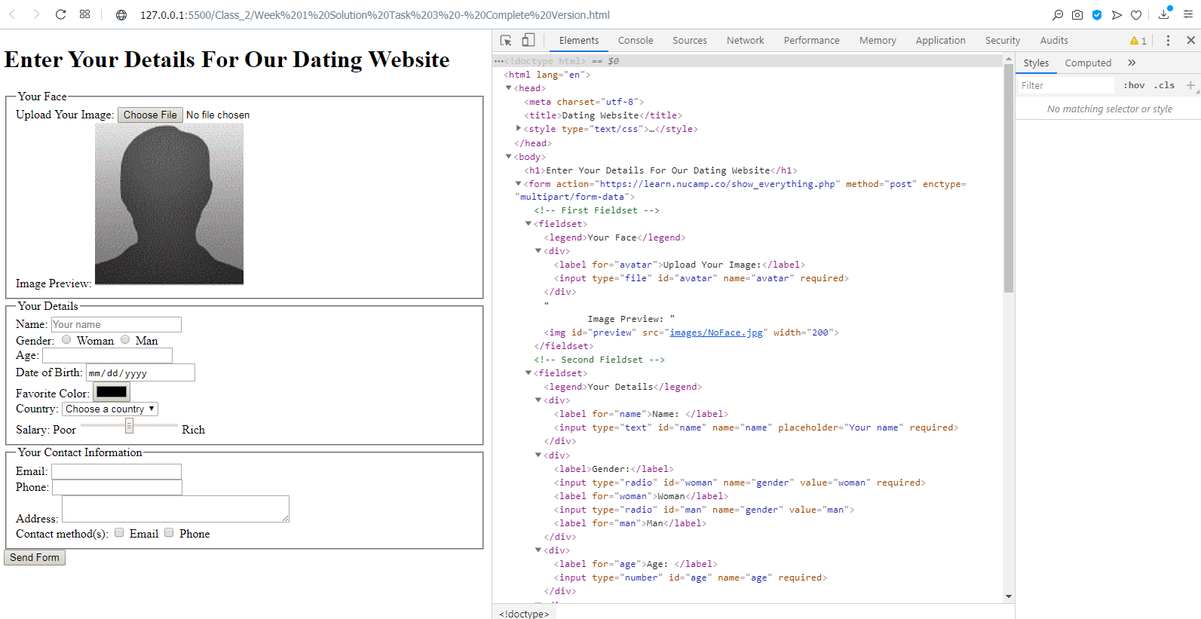

Save the file, and then open the file in your browser. Right click to inspect the code.

TASK 2: Apply visual styles using CSS
Now you will need to apply CSS to make the webpage look like the design given to you by the company. Below are important notes from the designer passed to you by the company. You must use this information in your work.

Use an internal/embedded stylesheet –  Add your CSS rulesets inside a style element in the head of your document.  Do not use inline styles. | <!DOCTYPE html>  <html lang="en">  <head>  <meta charset="UTF-8">  <meta name="viewport"  content="width=device-width, initial-scale=1.0">  <title>Date Me</title>  <style>  /* All Style goes here... see below */
- For the body element, set font-family to Verdana, Arial, sans-serif  Not part of the assignment, but to Center a Page add the following:  max-width to 66%, and  margin set to auto.  - For all legend elements, set background to purple,  set border-radius to 10px,  set color to white,  set padding to 12px  - For all fieldset elements, set background to lavender,  border to 10px solid darkblue,  border-radius to 20px,  margin-bottom to 10px, and  width to 720px  If you set the min-width to 250px, fieldsets will adjust for small devices  - For all div elements, set margin to 10px  - Use the Pseudo-Class “hover” for divs to change text color to blue  This is discussed in Task 3 below… but you can add it here…  - For all label elements, set display to inline-block,  text-align to right,  vertical-align to top,  width to 200px  If you set the min-width to 200px, labels will adjust for small devices  Also, setting white-space to pre will keep them from breaking  - Create a ruleset with this selector:  input[type="radio"]+label, input[type="checkbox"]+label  This selector targets all labels that are neighboring children of inputs with a type of radio or checkbox. While the code has been provided for you, please try to understand it before you continue.  For all elements matching this selector, set width to auto.  - For all elements with a .range-caption class, set background to darkcyan,  color to white, padding to 6px,  text-align to center  - For all input elements with a type of "submit"  (hint: use an attribute selector),  set background to darkcyan,  border-radius to 10px,  color to white,  font-size to 20px, and  padding to 12px. | body {  font-family: Verdana, Arial, sans-serif;  max-width: 66%; /* tweak to center page */  margin: auto; /* tweak to center page */  }  legend {  background: purple;  border-radius: 10px;  color: white;  padding: 12px;  }  fieldset {  background: lavender;  border: 10px solid darkblue;  border-radius: 20px;  margin-bottom: 10px;  /*width: 720px; */  min-width: 250px; /* tweak for small devices*/  }  div {  margin: 10px;  }  div:hover {  color: blue;  }  label {  display: inline-block;  text-align: right;  vertical-align: top;  /* width: 200px; */  max-width: 200px; /* tweak for small devices*/  white-space: pre; /* tweak for small devices*/  }  input[type="radio"]+label, input[type="checkbox"]+label {  width: auto;  }  input[type="range"]{width: 20%;} /* tweak for small devices*/  .range-caption {  background: darkcyan;  color: white;  padding: 6px;  text-align: center;  }  input[type="submit"] {  background: darkcyan;  border-radius: 10px;  color: white;  font-size: 20px;  padding: 12px;  }  </style>

At the end of Task 2, your assignment should look like this in the Chrome browser:
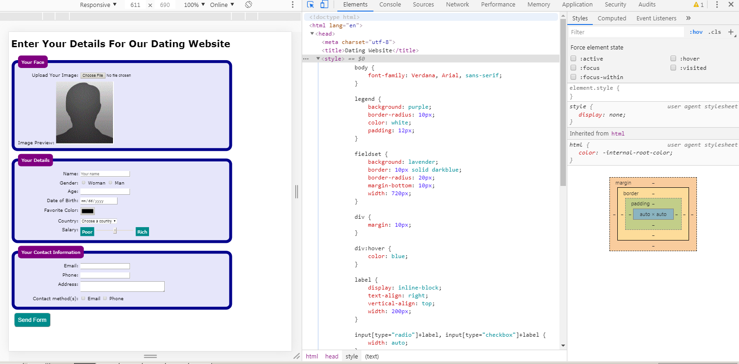

Save the file, and then open the file in your browser. Right click and inspect the code.

TASK 3: Add interactive features
For this task, two types of interactive behavior need to be added. These interactive behaviors are demonstrated in the accompanying video.
- In the internal stylesheet, add a ruleset with this selector: use a pseudo class of hover on all div elements. Add a declaration of color: blue. Already shown above in task 2 | div:hover {  color: blue;  }
- Add the following script element before the closing </body> tag. It is a link to a file containing JavaScript code. After this is added, the "Your Face" image will be immediately shown in the web page after the user uploads a file. The JavaScript code shows the selected image in the img element with id="preview" that you added in Task 1 under the file input.  <script src="https://url.nucamp.co/datingjs"></script> | <!-- Script for Image Preview -->  <script src="https://url.nucamp.co/datingjs"></script>  </body>  </html>  --------------------------------------------------------------------------------------------------  Here is what the script actually does… See below for a simpler approach.  <script>  window.onload = function() {  var files = document.querySelectorAll("input[type=file]");  files[0].addEventListener("change", function(e) {  if(this.files && this.files[0]) {  var reader = new FileReader();  reader.onload = function(e) {  document.getElementById("preview").setAttribute("src", e.target.result);  }  reader.readAsDataURL(this.files[0]);  }  });  }  </script>
- Not Part of the Assignment… but there is a much simpler script for an Image Preview. It is a function with one line of code. But you need to trigger the function from the form, (input type=”file”). | <script>  function ImgPreview(){  document.getElementById('preview').src = window.URL.createObjectURL(avatar.files[0])  //NOTE: URL.createObjectURL() can be used to create a reference to a File  // it doesn’t contain the actual File, but rather, it holds a reference to it.  }  </script>  You need to trigger the function from the form, input type=”file”  <input type="file" id="avatar" name="avatar" required onchange="ImgPreview()" />
- Not Part of the Assignment… but one more quick JS Script that will tweak (adjust) the Contact Method(s) checkboxes from braking when you adjust the screen size to small devices. But you need to trigger the function from the body tag. | <script>  function checkWidth(){  if(window.outerWidth <= 650){  document.getElementById("x").innerHTML = "<br>";  }  else{document.getElementById("x").innerHTML = ""}  }  </script>  But you need to trigger the function from the body tag.  <body onload="checkWidth()" onresize="checkWidth()">
External style: <link rel="stylesheet" type="text/css" href="../css/DateStyle.css">
Test the interactive features.
Submission
Once all three tasks are complete, upload the final version of datingform.html via the uploader below.
=-=-=-=-=-=-=-=-=-=-=-=-=-=-=-=--=-=-=-=-=-=-=-=-=-=-=-=--= Now… Just for fun… =-=-=-=-=-=-=-=-=-=-=-=-=-=-=-=-=-=--=-=-=-=-=-=-=-=-=-=-=--=
A Simple Responsive Web Site…
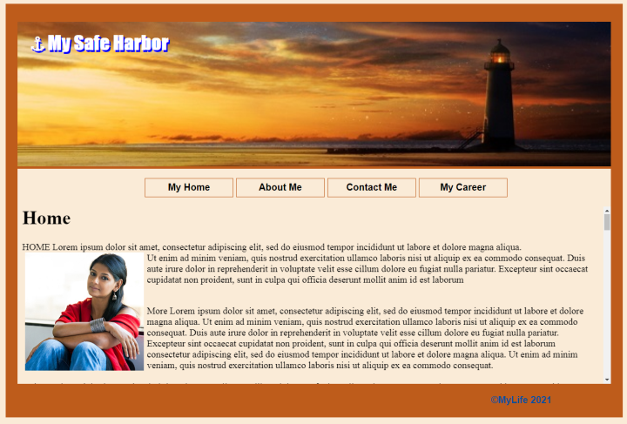
Build a one page responsive web site with 4 divisions and a CSS Horizontal menu.
Things you will need: (save your own or use these).
A Header Image such as: lighthouse2.jpg

A couple of more images if you want…

In your Class2 folder create a new file: Simple_Responsive.html
In your css folder create a new file: Horizontal_Menu.css
Here is the base code  In the Head you can add a favicon.  Also add a link to the empty stylesheet: Horizontal_Menu.css  (I put mine in my root directory CSS folder, hence the “../css/”)  Don’t forget your title.  And add a Style element, as there will be embedded css.  In the Body, there is one Main element, which is the container for everything else. Give it an ID of “Main”. We will use this to center the page. <main id="Main">  Next you need to add 4 divisions (div’s). One for each of the following:  - <div id="Banner"> Later we will add an image here…  - <div id="Menu"> This is where we add the Navigation element…  For now just add the “nav” tags and class “nav1”.  <nav class="nav1">  - <div id="Content"> Another division for our content  - <div id="Foot"> And one more for our footer. Go ahead and put in your copyright info: &copy;MyLife 2021  1 Banner  2 Nav  3 Content  4 ©MyLife 2021 | <!DOCTYPE html>  <html lang="en">  <head>  <meta charset="UTF-8">  <meta name="viewport" content="width=device-width, initial-scale=1.0">  <link rel="shortcut icon" href="../images/dp.gif">  <link rel="stylesheet" href="../css/Horizontal_Menu.css">  <title>Simple Responsive Web Site</title>  <style>  </style>  </head>  <body>  <main id="Main">  <div id="Banner">  1 Banner  </div>  <div id="Menu">  <nav class="nav1">  2 Nav  </nav>  </div>  <div id="Content">  3 Content  </div>  <div id="Foot">  4 &copy;MyLife 2021  </div>  </main>  </body>  </html>
- The First Division is the Banner <div id=" Banner">  Delete the text, and add an Image-Link with your header image as the “src”, and the “href” pointing to this page. | <div id=" Banner">  <a href="Simple_Responsive.html">  <img src="../images/lighthouse2.jpg" id="top" width="100%">  </a>  </div>
- Next let’s add the Navigation division… Delete the text: “Nav”.  This gets interesting. We will use an Unordered List to build a Horizontal dropdown menu.  Also notice that the “anchors” don’t do anything. yet…  We will add the links once we build the content (much like last week).  Also notice the z-index sets the style rule… more responsive  Without style it would look just like the unordered list we built in class last week.  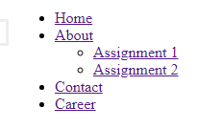  Next, build a Style Sheet.  We will remove the bullet points: list-style-type: none;  Also the “li”s are displayed on the same line: display: inline-block;  And the “ul”s inside of parent “ul”s are not shown: display: none;  Until you hover over the parent “li”: li:hover > ul { display: block;}  This is all the magic… everything else is just facade… | <div id="Menu">  <nav class="nav1">  <ul>  <li style="z-index: 4;"><a href="#" >Home</a></li>  <li style="z-index: 3;"><a href="#" >About</a>  <ul>  <li><a href="#" >Assignment 1</a></li>  <li><a href="#" >Assignment 2</a></li>  </ul>  </li>  <li style="z-index: 2;"><a href="#" >Contact</a></li>  <li style="z-index: 1;"><a href="#" >Career</a></li>  </ul>  </nav>  </div>  Copy the code below and paste it in your empty Horizontal_Menu.css file.  Use a separate file so that we don’t have to rewrite every time we use it
/* HorizontalMenu.css - Below is the Navigation Menu - Remember to change colors (background, font, etc..) as you like */  .nav1{  display: flex; /* Nav1 becomes a flex container */  justify-content: center; /* center aligns flex items */  /* add background color, font, text, etc., here */  }  .nav1 li {  display: inline-block; /* does not add a line-break */  list-style-type: none; /* no bullets */  position: relative; /* relative to its normal position */  width: 150px; /* up to you… any size will work */  }  .nav1 li ul {  display: none; /* nothing shown */  width: 100px; /* size of menu links */  position: absolute; /* relative to the nearest positioned ancestor */  left: 0px; /* position to parent */  top: 100%; /* position to parent */  margin: 0px; /* No margin or padding - or it wont work */  padding: 0;  } | .nav1 li:hover > ul {  display: block; /* on mouse-over we show the element */  }  .nav1 a {  padding: 5px 10px; /* Mostly for looks */  text-align: center; /* Mostly for looks */  height: 20px; /* Mostly for looks */  display: block; /* Required */  text-decoration: none; /* remove underline */  font-weight: bold; /* Mostly for looks */  border: #be5c1b 1px solid;  background-color: antiquewhite;  color:black;  /* add background color, font, text, etc., here */  }  .nav1 a:hover{ border: black 1px solid; /* add color, font, text, etc., here */ }  /* Above is the Nav Menu */
You now have your template… | A note on Web Templates… There are tons of them!  Look at these:  https://www.w3schools.com/w3css/w3css_templates.asp  or just google web templates  https://www.freewebtemplates.com
- Next let’s add the Content… Delete the text: “Content”.  Just use the content.html file from last week’s class. I made a copy and saved it as content 2.html in my class2 folder.  Below I also added some fake content that will also work…  If you don’t have the content.html file you can just use the following:  <div id="Content">  <section id="Home">  <h1>Home</h1>  <p>Lorem ipsum...<br><br><br><br><br><br><br><br><br><br><br><br><br><br><br><br><br><br></p>  </section>  <section id="About">  <h1>About</h1>  <p>Lorem ipsum...<br><br><br><br><br><br><br><br><br><br><br><br><br><br><br><br><br><br></p>  </section>  <section id="Career">  <h1> Career </h1>  <p>Lorem ipsum...<br><br><br><br><br><br><br><br><br><br><br><br><br><br><br><br><br><br></p>  </section>  <section id="Contact">  <h1> Career </h1>  <p>Lorem ipsum...<br><br><br><br><br><br><br><br><br><br><br><br><br><br><br><br><br><br></p>  </section>  <section id="Assignment1">  <h1> Assignment 1 </h1>  <p>Lorem ipsum...<br><br><br><br><br><br><br><br><br><br><br><br><br><br><br><br><br><br></p>  </section>  <section id="Assignment2">  <h1> Assignment 2 </h1>  <p>Lorem ipsum...<br><br><br><br><br><br><br><br><br><br><br><br><br><br><br><br><br><br></p>  </section>  </div> | <div id="Content">  <iframe src="content2.html" width="100%" height="300"  scrolling="yes" name="content" frameBorder="0" ></iframe>  </div>  Remember how iframes work… You embed an external page inside of your page.  Remember… the iframe has a name, and the <a> tag target attribute is referencing it  <div id="Content">  <iframe src="content2.html" width="100%" height="300"  scrolling="yes" name="content" frameBorder="0" ></iframe>  </div>  Also each dive in the content2.html file has an id which the <a> tag’s href attribute anchors to…  <div id="Home">
- The footer is done! so let’s do the embedded CSS. This is purely up to you… but there are a few rules that you may want to try…  Go back up to the head of the document…  Find the empty style <style></style>tags, and work through each element…  Start with the body… give it background and font colors, and a font family.  You can center the page using the main element. Just set its width to some percent of the total page size, and the set its margin to auto. I used 2/3rds of the total page size. Oh… and add a nice border…  Next style the Banner to center the image and keep the color consistent with the theme… You could use another flex container to center the image (flex latter..). Just use justify…  Next is the Content Div (which holds the iframe)  For the Content Div just set the height to 350px.  That leaves the Foot Division for last. Just give it a little background and text color, and align it right, and maybe a little padding.  So now everything is styled… but how do we get the menu to show the different sections? Let’s use iframes… | <style>  body{  background-color:antiquewhite;  color:darkblue;  font-family: Arial, Helvetica, sans-serif;  }  main{/* This will center the page */  width: 66%;  margin: auto;  border:#be5c1b 20px solid;  }  #banner{  /*display: flex; /* used to center align the image */  justify-content: center;  background-color:#be5c1b;  border-top:#be5c1b 10px solid;  }  #Content{height:350px; } /* For consistant size */  #Foot{  background-color:#be5c1b;  color: #094f9e;  font-weight:bold;  text-align: right;  padding-right: 10%;  }  </style>
- All that’s left to do is to wire-up the menu links…  Go back to the menu div and add your targets and anchors within the iframe.  Remember… the iframe has a name, and the <a> tag target attribute is referencing (talking to) it  <div id="Content">  <iframe src="content2.html" width="100%" height="300"  scrolling="yes" name="content" frameBorder="0" ></iframe>  </div>  Also each div in the content2.html file has an id, which the <a> tag’s href attribute is anchored to…  <a href="content2.html#Home" target="content">Home</a>  <div id="Home"> | <div id="Menu">  <nav class="nav1">  <ul>  <li style="z-index: 4;">  <a href="content2.html#Home" target="content">Home</a>  </li>  <li style="z-index: 3;">  <a href="content2.html#About" target="content">About</a>  <ul>  <li>  <a href="content2.html#Assignment1"  target="content">Assignment 1</a>  </li>  <li>  <a href="content2.html#Assignment2"  target="content">Assignment 2</a>  </li>  </ul>  </li>  <li style="z-index: 2;">  <a href="content2.html#Contact" target="content">Contact</a>  </li>  <li style="z-index: 1;">  <a href="content2.html#Career" target="content">Career</a>  </li>  </ul>  </nav>  </div>
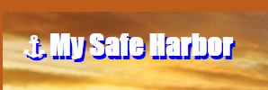
That’s it… unless you want to make a text-only logo…

Go back to the banner div,  Add two internal/child divs with some text and a unique id.  &#9875; = ANCHOR | <div id="banner">  <a href="Simple_Responsive.html">  <img src="../images/lighthouse2.jpg" id="top" width="100%">  </a>  <div id="logo1">&#9875; My Safe Harbor </div>  <div id="logo2">&#9875; My Safe Harbor </div>  </div>
Then go back to your style sheet or embedded style tags…  Add the following:  Positon the banner to relative  Logo1 and Logo2 are the same  So make them the same… and then change the color of one  Positioning the two to the banner is what gives the shading effect. | /* Below is for the My Safe Harbor logo */  #banner{position: relative;} /* Needed for logo to position to... */  #logo1, #logo2{  color:white;  font-size: xx-large;  font-family: Impact, Haettenschweiler, 'Arial Narrow Bold', sans-serif;  font-weight: bolder;  padding:5px;  }  #logo1{color:blue;}  # banner #logo1{  position: absolute; top:5%; left: 2%;  }  # banner #logo2{  position: absolute; top:4.75%; left: 1.75%;  }  /* Above is for the My Safe Harbor logo */

Embedded YouTube videos:
Developers Hack…
YouTube decided that they won’t allow IP addresses to access embedded videos…
So… Just Change your IP to a URL: (You have to do it in the address bar)
http://127.0.0.1:5500/Lectures2/Simple_Responsive.html
http://localhost:5500/Lectures2/Simple_Responsive.html

Below is the final code…

Completed Code:
DateMe.html

<!DOCTYPE html>
<html lang="en">
<head>
<meta charset="UTF-8">
<meta name="viewport"
content="width=device-width, initial-scale=1.0">
<title>Date Me</title>
<style>

body {
font-family: Verdana, Arial, sans-serif;
max-width: 66%; /* tweak to center page */
margin: auto; /* tweak to center page */
}
legend {
background: purple;
border-radius: 10px;
color: white;
padding: 12px;
}

fieldset {
background: lavender;
border: 10px solid darkblue;
border-radius: 20px;
margin-bottom: 10px;
/*width: 720px; */
min-width: 250px; /* tweak for small devices */
}

div {
margin: 10px;
}
div:hover {
color: blue;
}

label {
display: inline-block;
text-align: right;
vertical-align: top;
/* width: 200px; */
max-width: 200px; /* tweak for small devices */
white-space: pre; /* tweak for small devices */
}
input[type="radio"]+label, input[type="checkbox"]+label {
width: auto;
}
input[type="range"]{width: 20%;} /* tweak for small devices */
.range-caption {
background: darkcyan;
color: white;
padding: 6px;
text-align: center;
}
input[type="submit"] {
background: darkcyan;
border-radius: 10px;
color: white;
font-size: 20px;
padding: 12px;
}
</style>
</head>
<body onload="checkWidth()" onresize="checkWidth()"> <!--CheckWidth tweak -->
<h1>Enter Your Details For Our Dating Website</h1>
<form action="results.html" method="get">
<!-- <form action="https://learn.nucamp.co/show_everything.php"
method="post" enctype="multipart/form-data"> -->
<!-- First Fieldset -->
<fieldset>
<legend>Your Face</legend>
<div>
<label for="avatar">Upload Your Image:</label>
<input type="file" id="avatar" name="avatar" required onchange="ImgPreview()" />
</div>
Image Preview:
<img id="preview" src="images/NoFace.jpg" width="200" />
</fieldset>
<!-- Second Fieldset -->
<fieldset>
<legend>Your Details</legend>
<div>
<label for="name">Name: </label>
<input type="text" id="name" name="name"
placeholder="Your name" required />
</div>
<div>
<label>Gender:</label>
<input type="radio" id="woman" name="gender"
value="woman" required/>
<label for="woman">Woman</label>
<input type="radio" id="man" name="gender" value="man" />
<label for="man">Man</label>
</div>
<div>
<label for="age">Age: </label>
<input type="number" id="age" name="age" required />
</div>

<div>
<label for="dob">Date of Birth: </label>
<input type="date" id="dob" name="dob" />
</div>
<div>
<label for="color">Favorite Color:</label>
<input type="color" id="color" name="color" />
</div>
<div>
<label for="country">Country:</label>
<select id="country" name="country">
<option>Choose a country</option>
<option value="brazil">Brazil</option>
<option value="france">France</option>
<option value="japan">Japan</option>
<option value="libya">Libya</option>
<option value="usa" selected>U.S.A.</option>
</select>
</div>
<div>
<label for="salary">Salary:</label>
<span class="range-caption">Poor</span>
<input type="range" id="salary" name="salary"
min="0" max="100" value="50" >
<span class="range-caption">Rich</span>
</div>
</fieldset>
<!-- Third Fieldset -->
<fieldset>
<legend>Your Contact Information</legend>
<div>
<label for="email">Email: </label>
<input type="email" id="email" name="email" required />
</div>
<div>
<label for="phone">Phone: </label>
<input type="tel" id="phone" name="phone" />
</div>
<div>
<label for="address">Address: </label>
<!-- Inline Style tweak for textarea -->
<textarea style="max-width:100%; width:400px" id="address" name="address"></textarea>
</div>
<div>
<label>Contact method(s): </label>
<span id="x"></span><!-- Span is a tweak fo checkWidth()-->
<input type="checkbox" name="contact1"
id="emailCheckbox" value="email" />
<label for="emailCheckbox">Email</label>
<input type="checkbox" name="contact2"
id="phoneCheckbox" value="phone" />
<label for="phoneCheckbox">Phone</label>
</div>
</fieldset>
<!-- Submit Input -->
<div>
<input type="submit" value="Click To Submit" />
</div>
</form>
<!--<script src="https://url.nucamp.co/datingjs"></script> -->
<!-- Below is an alternative to the nucamp js to preview image, but you have to add a trigger to input type="file" -->
<script>
function ImgPreview(){
document.getElementById('preview').src = window.URL.createObjectURL(avatar.files[0])
//NOTE: URL.createObjectURL() can be used to create a reference to a File
// it doesn’t contain the actual File, but rather, it holds a reference to it.
}
</script>
<script> //This is a tweak to make check boxes work when using smart phone
function checkWidth(){
if(window.outerWidth <= 650){
document.getElementById("x").innerHTML = "<br>";
}
else{document.getElementById("x").innerHTML = ""}
}
</script>
</body>
</html>

Completed Results.html Code for Get Method (Save this code in your class folder):
<!DOCTYPE>
<html>
<head>
<title>Parsing URL Query String Using only Javascript</title>

<script type="text/javascript">
// Build an empty URL structure in which we will store the individual query values by key.
var objURL = new Object();
// Use the “string”.replace method to iterate over each name-value pair in the query string.
window.location.search.replace(
new RegExp( "([^?=&]+)(=([^&]*))?", "g" ),
// Regular expressions are patterns used to match character combinations in strings.
// For each matched query string pair, add that pair to the URL structure
// using the equals value as the key.
//$'s are not a "variable", they are a placeholders that are used in the .replace() call. $n represents the nth capture group of the regular expression.
//$1 is whatever is matched in the first capture. If you have more captures you can use $2, $3 etc…
function( $0, $1, $2, $3 ){ objURL[ $1 ] = $3; }
);
</script>
</head>
<body>
<p>
<h1>Results - Parsing URL Query String Using only Javascript (with RegExp)</h1>
<h2>Push this to your Database</h2>
</p>
<p>
<script type="text/javascript">
// Loop over the URL values that you collected.
document.write("<table>")
for (var strKey in objURL){
// Output the key to the document.
document.write(
"<tr><td><strong>" + strKey + ":</strong></td>"
);
// replace "%23" to "#"", "%40" to "@", "+"" to " "
objURL[ strKey ] = objURL[ strKey ].replace(/%23/g, "#");
objURL[ strKey ] = objURL[ strKey ].replace(/%40/g, "@");
objURL[ strKey ] = objURL[ strKey ].replace(/\+/g, " ");
// Output the value stored at that key.
document.write(
"<td>" +objURL[ strKey ] + "</td></tr>"
);
}
document.write("</table>")
</script>
</p>
<p>Rem: This does not handle the image blob</p>
</body>
</html>

Below is the Simple Responsive Menu code
Final Code
Simple_Responsive.html

<!DOCTYPE html>
<html lang="en">
<head>
<meta charset="UTF-8">
<meta name="viewport" content="width=device-width, initial-scale=1.0">
<link rel="shortcut icon" href="../images/dp.gif">
<link rel="stylesheet" href="../css/Horizontal_Menu.css">
<title>Simple Responsive Web Site</title>
<style>
body{
background-color:antiquewhite;
color:darkblue;
font-family: Arial, Helvetica, sans-serif;
}
main{/* This will center the page */
width: 66%;
margin: auto;
border:#be5c1b 20px solid;
}
#banner{
/*display: flex; /* used to center align the image */
justify-content: center;
background-color:#be5c1b;
border-top:#be5c1b 10px solid;
}
#Content{height:350px; } /* For consistant size */
#Foot{
background-color:#be5c1b;
color: #094f9e;
font-weight:bold;
text-align: right;
padding-right: 10%;
}
/* Below is for the My Safe Harbor logo */
#banner{position: relative;} /* Needed for logo to position to... */
#logo1, #logo2{
color:white;
font-size: xx-large;
font-family: Impact, Haettenschweiler, 'Arial Narrow Bold', sans-serif;
font-weight: bolder;
padding:5px;
}
#logo1{color:blue;}
#banner #logo1{
position: absolute; top:5%; left: 2%;
}
#banner #logo2{
position: absolute; top:4.75%; left: 1.75%;
} /* Above is for the My Safe Harbor logo */
</style>
</head>
<body>
<main id="Main">
<div id="banner">
<a href="Simple_Responsive.html">
<img src="../images/lighthouse2.jpg" id="top" width="100%">
</a>
<div id="logo1">&#9875; My Safe Harbor </div>
<div id="logo2">&#9875; My Safe Harbor </div>
</div>
<div id="Menu">
<nav class="nav1">
<ul>
<li style="z-index: 4;">
<a href="content2.html#Home" target="content">Home</a>
</li>
<li style="z-index: 3;">
<a href="content2.html#About" target="content">About</a>
<ul>
<li>
<a href="content2.html#Assignment1"
target="content">Assignment 1</a>
</li>
<li>
<a href="content2.html#Assignment2"
target="content">Assignment 2</a>
</li>
</ul>
</li>
<li style="z-index: 2;">
<a href="content2.html#Contact" target="content">Contact</a>
</li>
<li style="z-index: 1;">
<a href="content2.html#Career" target="content">Career</a>
</li>
</ul>
</nav>
</div>
<div id="Content">
<iframe src="content2.html" width="100%" height="300"
scrolling="yes" name="content" frameBorder="0" ></iframe>
</div>
<div id="Foot">
<br> &copy;MyLife 2021
</div>
</main>
</body>
</html>

Horizontal_Menu.css

.nav1{
display: flex; /* Nav becomes a flex container */
justify-content: center; /* center aligns flex items */
}
.nav1 li {
display: inline-block; /* does not add a line-break */
list-style-type: none; /* no bullets */
position: relative; /* relative to its normal position */
width: 150px; /* any size will work */
}
.nav1 li ul {
display: none; /* not shown */
width: 100px; /* size of menu links */
position: absolute; /* relative to the nearest positioned ancestor */
left: 0px; /* position to parent */
top: 100%; /* position to parent */
margin: 0px; /* No margin or padding - or it wont work */
padding: 0;
}
.nav1 li:hover > ul {
display: block; /* on mouse-over we show the element */
}
.nav1 a {
padding: 5px 10px; /* Mostly for looks */
text-align: center; /* Mostly for looks */
height: 20px; /* Mostly for looks */
display: block; /* Required */
text-decoration: none; /* remove underline */
font-weight: bold; /* Mostly for looks */
border: #be5c1b 1px solid;
}
.nav1 a:hover{ border: black 1px solid; }

content2.html

<div id="Home">
<h1>Home<br/></h1>
<p>
HOME Lorem ipsum dolor sit amet, consectetur adipiscing elit, sed do eiusmod tempor incididunt ut labore et dolore magna aliqua. Ut enim ad minim veniam, quis nostrud exercitation ullamco laboris nisi ut aliquip ex ea commodo consequat. Duis aute irure dolor in reprehenderit in voluptate velit esse cillum dolore eu fugiat nulla pariatur. Excepteur sint occaecat cupidatat non proident, sunt in culpa qui officia deserunt mollit anim id est laborum<br><br>
<img src="../images/joanne.jpg" height="200" align="left" hspace="5" alt="joanne">
</p>
<p>
More Lorem ipsum dolor sit amet, consectetur adipiscing elit, sed do eiusmod tempor incididunt ut labore et dolore magna aliqua. Ut enim ad minim veniam, quis nostrud exercitation ullamco laboris nisi ut aliquip ex ea commodo consequat. Duis aute irure dolor in reprehenderit in voluptate velit esse cillum dolore eu fugiat nulla pariatur. Excepteur sint occaecat cupidatat non proident, sunt in culpa qui officia deserunt mollit anim id est laborum consectetur adipiscing elit, sed do eiusmod tempor incididunt ut labore et dolore magna aliqua. Ut enim ad minim veniam, quis nostrud exercitation ullamco laboris nisi ut aliquip ex ea commodo consequat.<br><br>
Duis aute irure dolor in reprehenderit in voluptate velit esse cillum dolore eu fugiat nulla pariatur. Excepteur sint occaecat cupidatat non proident, sunt in culpa qui officia deserunt mollit anim id est laborum consectetur adipiscing elit, sed do eiusmod tempor incididunt ut labore et dolore magna aliqua. Ut enim ad minim veniam, quis nostrud exercitation ullamco laboris nisi ut aliquip ex ea commodo consequat
</p>
</div>

<div id="About">
<h1>About</h1>
<p>
About Lorem ipsum dolor sit amet, consectetur adipiscing elit, sed do eiusmod tempor incididunt ut labore et dolore magna aliqua. Ut enim ad minim veniam, quis nostrud exercitation ullamco laboris nisi ut aliquip ex ea commodo consequat. Duis aute irure dolor in reprehenderit in voluptate velit esse cillum dolore eu fugiat nulla pariatur. Excepteur sint occaecat cupidatat non proident, sunt in culpa qui officia deserunt mollit anim id est laborum. Excepteur sint occaecat cupidatat non proident, sunt in culpa qui officia deserunt mollit anim id est laborum consectetur adipiscing elit, sed do eiusmod tempor incididunt ut labore et dolore magna aliqua. Ut enim ad minim veniam, quis nostrud exercitation ullamco laboris nisi ut aliquip ex ea commodo consequat.
</p>
<img src="../images/nucamp.png">
<p>
More Lorem ipsum dolor sit amet, consectetur adipiscing elit, sed do eiusmod tempor incididunt ut labore et dolore magna aliqua. Ut enim ad minim veniam, quis nostrud exercitation ullamco laboris nisi ut aliquip ex ea commodo consequat. Duis aute irure dolor in reprehenderit in voluptate velit esse cillum dolore eu fugiat nulla pariatur.
Excepteur sint occaecat cupidatat non proident, sunt in culpa qui officia deserunt mollit anim id est laborum consectetur adipiscing elit, sed do eiusmod tempor incididunt ut labore et dolore magna aliqua. Ut enim ad minim veniam, quis nostrud exercitation ullamco laboris nisi ut aliquip ex ea commodo consequat.Excepteur sint occaecat cupidatat non proident, sunt in culpa qui officia deserunt mollit anim id est laborum consectetur adipiscing elit, sed do eiusmod tempor incididunt ut labore et dolore magna aliqua. Ut enim ad minim veniam, quis nostrud exercitation ullamco laboris nisi ut aliquip ex ea commodo consequat.<br>
</p>
</div>
<hr/>
<div id="Assignment1">
<h1>Assignment 1</h1>
<iframe src="../Class1/profile_Ben.html" width="70%" height="450" scrolling="yes" frameborder="0"></iframe>
</div>
<div id="Assignment2">
<h1>Assignment 2</h1>
<iframe src="../Class2/dateMe.html" width="70%" height="450" scrolling="yes" frameborder="0"></iframe>
</div>
<hr/>
<div id="Contact">
<h1>Contact</h1>
<p>
Assignment Lorem ipsum dolor sit amet, consectetur adipiscing elit, sed do eiusmod tempor incididunt ut labore et dolore magna aliqua. Ut enim ad minim veniam, quis nostrud exercitation ullamco laboris nisi ut aliquip ex ea commodo consequat. Duis aute irure dolor in reprehenderit in voluptate velit esse cillum dolore eu fugiat nulla pariatur. Excepteur sint occaecat cupidatat non proident, sunt in culpa qui officia deserunt mollit anim id est laborum
</p>
<center><img src="../images/DOM.jpg" width="66%"></center>
<p>
More Lorem ipsum dolor sit amet, consectetur adipiscing elit, sed do eiusmod tempor incididunt ut labore et dolore magna aliqua. Ut enim ad minim veniam, quis nostrud exercitation ullamco laboris nisi ut aliquip ex ea commodo consequat. Duis aute irure dolor in reprehenderit in voluptate velit esse cillum dolore eu fugiat nulla pariatur. Excepteur sint occaecat cupidatat non proident, sunt in culpa qui officia deserunt mollit anim id est laborum consectetur adipiscing elit, sed do eiusmod tempor incididunt ut labore et dolore magna aliqua. Ut enim ad minim veniam, quis nostrud exercitation ullamco laboris nisi ut aliquip ex ea commodo consequat.<br>
</p>
</div>

