Simple Image Link Buttons using the Paint Application
- Open Paint and set up a template (100 px by 25 px)
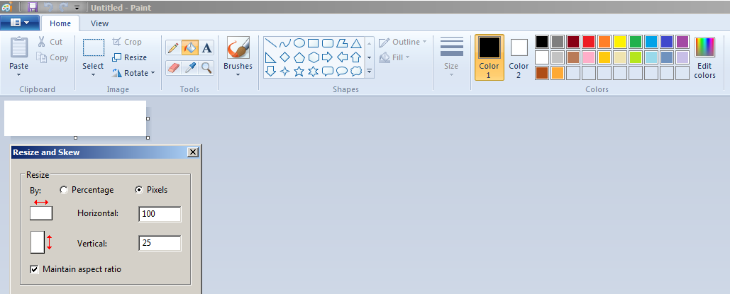

- Fill in the background color (Black or whatever color you like…)
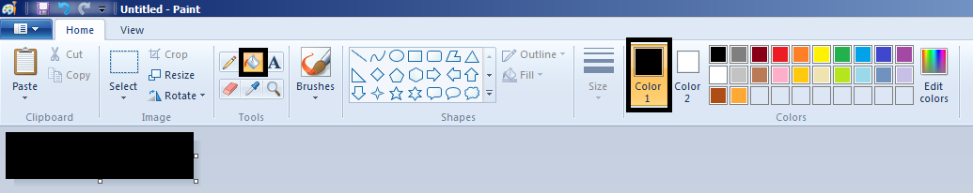

- Select the Text tool
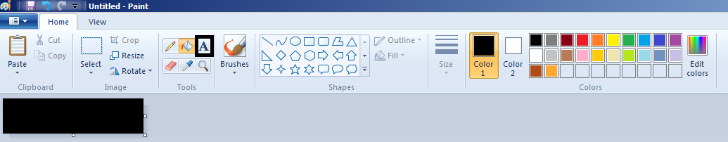

- Next select the font color, size, etc. Then type in your menu name. Align it manually.
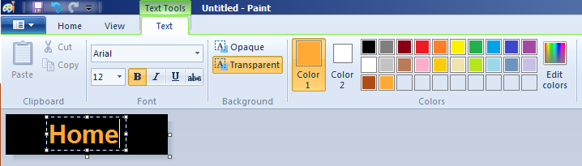

- Select: File, Save As. Pick a format (PNG, JPG, etc).
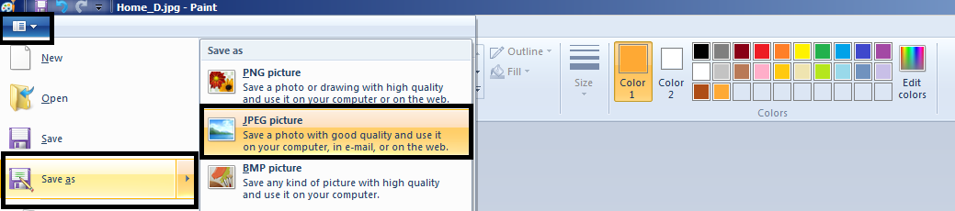

- Pick a folder, give the image a name, and select Save.
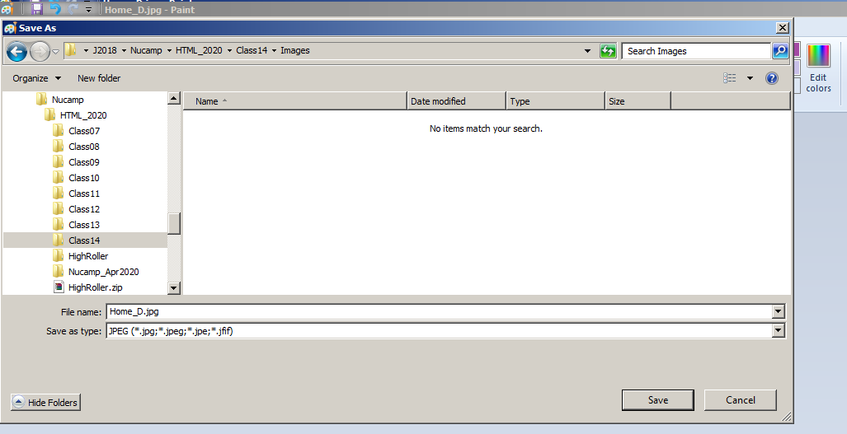

- After saving… hit the Undo button once. You now have a blank template for your next button
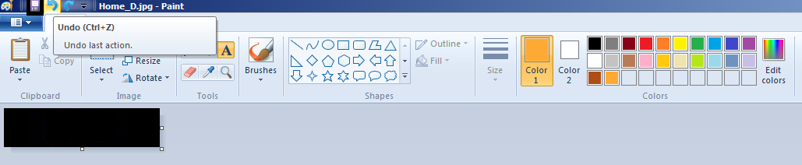

- Follow the same steps from step 3 to create as many buttons as needed.
Images used in Class 1:







