The Document Object Model

The Document Object Model (DOM) is a description of how an HTML (or XML) document is represented in a tree-like structure. The tree represents the various types of content in a document - primarily types of content (nodes) representing elements or tags (such as <body> and <p>).

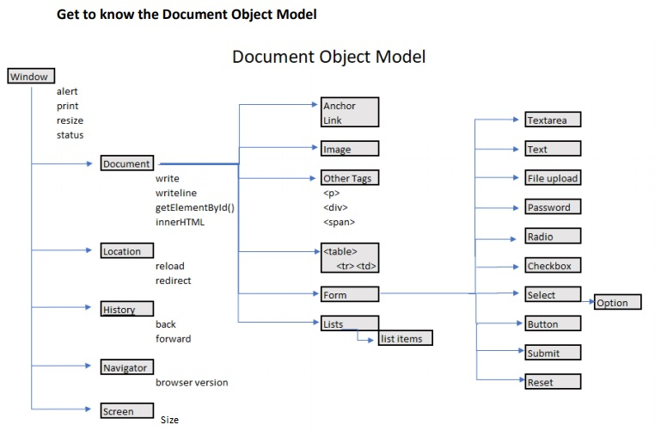
This model (the DOM of HTML, XHTML, and XML documents on the Internet)
gives the JavaScript/ECMAScript language a mapping structure. HTML
documents have a hierarchical structure that is represented in the DOM
as a tree structure.

Below is another depiction of the DOM (Document Object Model) The Document Object Model is both platform-neutral and language-neutral.

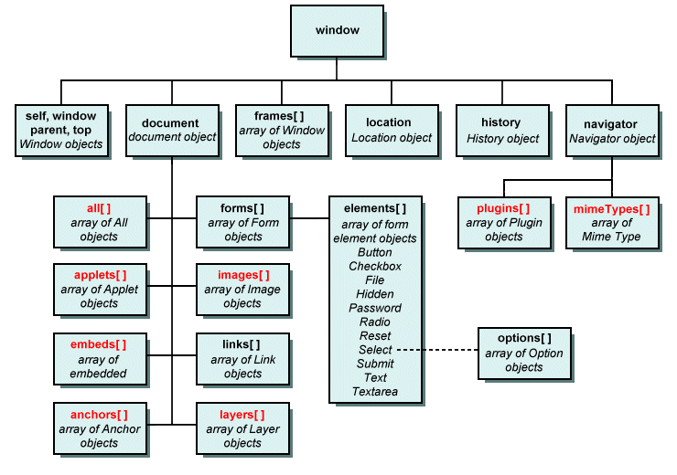
The Document Object Model (DOM) is actually an application programming interface (API) for manipulating HTML documents...
It represents a document as a tree of nodes.
It allows you to effectively add, remove, and modify parts of the document.
Consider the following HTML document:
The DOM Mapping represents parent and child nodes of the HTML document.
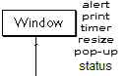
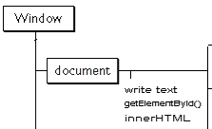
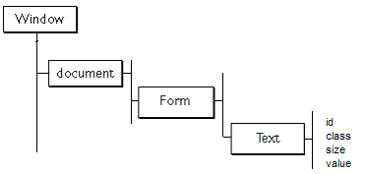
X = window.document.formName.elementName.value
or
window.document.form01.textBox01.value = “Nucamp”
o Mapping the DOM
The concept of "." Dot Syntax is used to combine objects (or
element) with names, methods, and properties.
For example:
window.document.write("Hello Nucamp");
below is the Window object with a property
window.status = "Nucamp HTML CSS and JS.";
next is an object with a method:
And finally to map an element in the DOM:
form01
textBox01

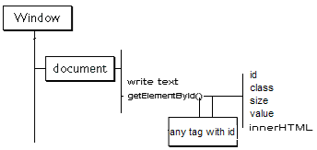
Sometimes you will also see Array Notation
document.getElementById(‘elementID’).method/property

querySelector vs getElementById
querySelector is a little slower but easy to use…

x = document.querySelector (‘.elementID’).method/property
x =
//Array Notation
document.forms[0].elements[0].text
* * * A Common Approach for mapping the DOM * * *
x =

