Objectives
- Use the knowledge you have gained about HTML to create a profile page.
- Introduce yourself to your instructor and classmates in more detail.

Be Creative… Have fun!!!
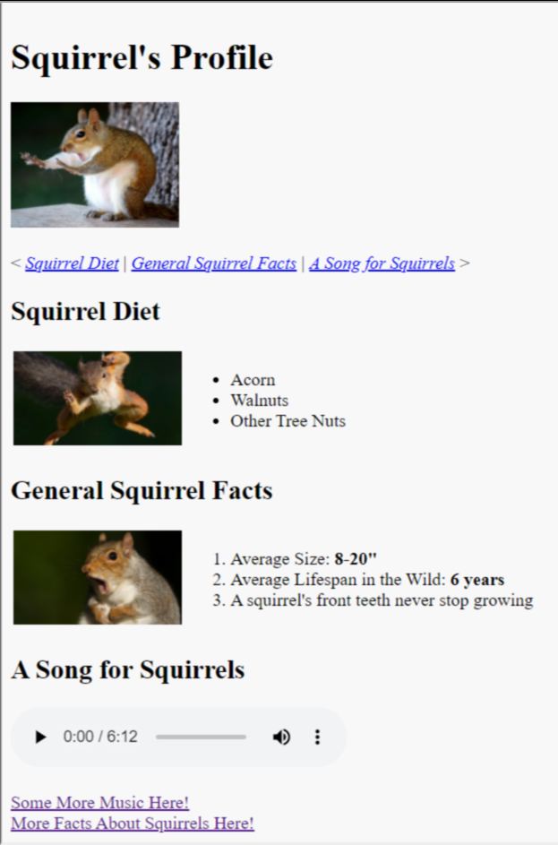

BEFORE YOUR WORKSHOP
- Find and place at least two image files in the images subfolder inside your course folder. One should be a photo to use as a profile photo. The others can be of anything that would make sense to include in a profile page about you - it could be a photo of you, your family, your pets, a favorite place or hobby, etc.
- Create an mp3s subfolder in your course folder and locate and place an mp3 file of your choice inside it. If you do not have one to use, you can search online for "download sample mp3s" and download one. (See the Assignment Resources at the bottom of this page for a couple of options.) AudioHelix mp3 example files
- Read the workshop instructions below and watch the accompanying video, but do not yet start on the assignment instructions.

Instructions  Task 1: Create and set up your profile.html page  - Create a new HTML document named profile.html inside your course folder.  - Set it up as you learned to do in the Set Up an HTML Document exercise, with an appropriate title such as "Profile - Jane Smith".  - At the top of the <body> element, add the <h1> element with Profile - (your name) as its text content.  - Beneath the <h1> element, create two <section> elements. | <!DOCTYPE html>  <html lang="en">  <head>  <meta charset="UTF-8">  <meta name="viewport"  content="width=device-width, initial-scale=1.0">  <title>My Profile</title>  </head>  <body bgcolor="#ffffff">  <h1> My Profile Page </h1>  <section>  </section>  <section>  </section>  </body>  </html>
Task 2: Fill in your profile  - In the first <section> element, first add your profile photo using the <img> element. Don't forget to add a descriptive alt text.  - Beneath it, add an <h2> element with the text content "About Me".  - Beneath it, add an unordered list. In separate listitems, provide this information:  - Where were you born?  - Where do you live now?  - Provide the answer to at least 2 or more other questions from the Ice Breaker questionnaire you took earlier this week.  - Optionally, add any other information about yourself here that you might like to share!  - In the second <section> element, add another <h2> element with the text content "Interests".  - Beneath this, create another unordered list to list some of your interests and hobbies. | <!DOCTYPE html>  <html lang="en">  <head><!-- See above --></head>  <body bgcolor="#ffffff">  <h1> My Profile Page </h1>  <section>  <img src="images/MyImg.jpg" alt="My Picture">  <h2>About Me</h2>  <ul>  <li>Born in Boston</li>  <li>I lived in Philadelphia</li>  <li>I like HTML</li>  <li>I enjoyed writing the Constitution</li>  </ul>  </section>  <section>  <h2>My Interests</h2>  <ol>  <li>Writing</li>  <li>Politics</li>  <li>Flying Kites</li>  </ol>  </section>  </body>  </html>
Task 3: Add an <audio> element  - This is where you will use the MP4 file that you downloaded and added to an mp4s folder as instructed in the "Before Your Workshop" section above. If you skipped this part, go back and follow those instructions now.  - Add an <audio> element on your webpage where you deem appropriate.  - The <audio> element works almost exactly like the <video> element.  - It supports MP3, OGG, and WAV file formats.  - Give it a src attribute with a relative path to your mp3 file.  - Also give it a Boolean attribute of controls. You can add loop to it as well, if you wish.  - inside the start and end tags, add this text content, replacing where it says YourAudioFileNameHere with your actual audio file's name:  Your browser does not support HTML5 audio. Here is  <a href="mp3s/YourAudioFileNameHere.mp3">a link to the  audio</a> instead.  Free classical MP3 sound samples  Below is an alternate approach for the audio element with alternative choices  <audio controls>  <source src="Classical.mp3" type="audio/mp3" >  <source src="../media/Audio_File.mp3" type="audio/mp3" />  Your browser does not support the audio!  </audio> | <!DOCTYPE html>  <html lang="en">  <head><!-- See above --></head>  <body bgcolor="#ffffff">  <h1> My Profile Page </h1>  <section>  <img src="images/MyImg.jpg" alt="My Picture">  <h2>About Me</h2>  <ul>  <li>Born in Boston</li>  <li>I lived in Philadelphia</li>  <li>I like HTML</li>  <li>I enjoyed writing the Constitution</li>  </ul>  </section>  <section>  <h2> My Interests</h2>  <ul>  <li>Writing</li>  <li>Politics</li>  <li>Flying Kytes</li>  </ul>  </section>  <h2>A Song Just for you</h2>  <audio controls src="music/Classical.mp3" type="audio/mp3">  Get a better browser.  </audio><br>  <a href="http://www.orangefreesounds.com/classical-guitar-music/">  Get this and other Free MP3's Here</a><br>  <a href="http://drpage.net/nucamp">Dan's Page</a>  </body>  </html>  -=-==--=-==-=-=-=-=--== OR -==-=-=-==-=-=--==-=-=-=-=-  <audio controls>  <source src="../../media/String-Guitar-C4.wav" type="audio/wav" />  <source src="../../media/my_Audio_File.mp3" type="audio/mpeg" />  No Audio  </audio>
Task 4: Enhance your profile  - Use your judgment to place your other image file(s) in an appropriate place or places within your document. It or they might belong in the first section, the second section, or even a new section.  - Use the <a> element to add at least two hyperlinks of your choice. These can be in the form of links to other webpages, a link to another section of the same page, or a link to your phone or email. Two is the minimum; you can add as many as you wish!  - Add <em> and/or <strong> elements if appropriate. Use your discretion. If there is not any content that would require these elements, you don't need to add them.  - If there is still time left in the workshop, you can add more content to your profile, or try using your profile page to play with a new element that you haven't used yet. See the Assignment Resources below for links to both W3Schools and MDN's HTML element references pages. You won't be graded on this, but it would be a wise use of your time! | <!DOCTYPE html>  <html lang="en">  <head>  <meta charset="UTF-8">  <meta name="viewport"  content="width=device-width, initial-scale=1.0">  <title>My Profile</title>  </head>  <body bgcolor="#ffffff">  <h1> My Profile Page </h1>  <section>  <img src="images/MyImg.jpg" alt="My Picture">  <h2>About Me</h2>  <ul>  <li>Born in <em>Boston</em></li>  <li>I lived in Philadelphia</li>  <li>I like HTML</li>  <li>I enjoyed writing the Constitution</li>  </ul>  </section>  <section>  <h2> My Interests</h2>  <ul>  <li>Writing</li>  <li>Politics</li>  <li>Flying <strong>Kites</strong></li>  </ul>  </section>  <h2>A <em>Song</em> Just for you</h2>  <audio controls src="music/Classical.mp3" type="audio/mpeg">  Get a better browser.  </audio><br>  <a href="http://www.orangefreesounds.com/classical-guitar-music/">  Get this and other Free MP3's Here </a><br>  <a href="http://drpage.net/nucamp">Dan's Page</a>  </body>  </html>

Test
- Open the page you created in your browser with Live Server.
Adding Social Media Links
<a href=" https://www.facebook.com/nucamp.co/" target="_blank">
<img src="../images/facebook.jpg" width="33"><br>Nucamp
</a>
<a href=" https://twitter.com/explore" target="_blank">
<img src='../images/twitter.gif' width='33' /><br>Twitter
</a>&nbsp;
<a href=https://www.youtube.com/watch?v=58TBZnvyGwQ" target="_blank">
<img src='../images/YouTube.jpg' width='33' />
</a>&nbsp;
Embedding a YouTube Video
You simply need to go to YouTube, play the video that you would like to embed, click the share button, and then click on the Embed button in order to copy the YouTube embed code. After that, you can paste the code in the editable code of your blog or website.
<iframe width="560" height="315" src="https://www.youtube.com/embed/6iuctWusJ7w" title="YouTube video player" frameborder="0" allow="accelerometer; autoplay; clipboard-write; encrypted-media; gyroscope; picture-in-picture" allowfullscreen></iframe>
- Verify that your images and text all load correctly.
- Verify that all links are functioning.
- Verify that the embedded audio player is functioning.


Submission
- Submit your profile.html page, along with a screenshot of your working webpage as shown in your browser.
  - In Chrome, you can use the extension Full Page Screen Capture to create a single screenshot of the full page. There's one other option you can explore through this link.
  - In Firefox, follow these instructions for a full page screenshot.
  - Do not submit your image or mp3 files.

Assignment Resources

Sample MP3 Dowload Sites
- Free classical MP3 sound samples (right/control+click and Save link as to download)
- AudioHelix mp3 example files

HTML Element References
- MDN - The <audio> embed element
- W3Schools - HTML Element Reference
- MDN - HTML elements reference

Taking Screenshots
- Chrome extension - Full Page Screen Capture
- Zapier.com - Full page screenshots in Chrome
- Firefox Screenshots (full page)
- The Verge - How to take screenshots (not full page)

