Byethost - Free Web Hosting
- Go to: https://byet.host/
- Click the free hosting
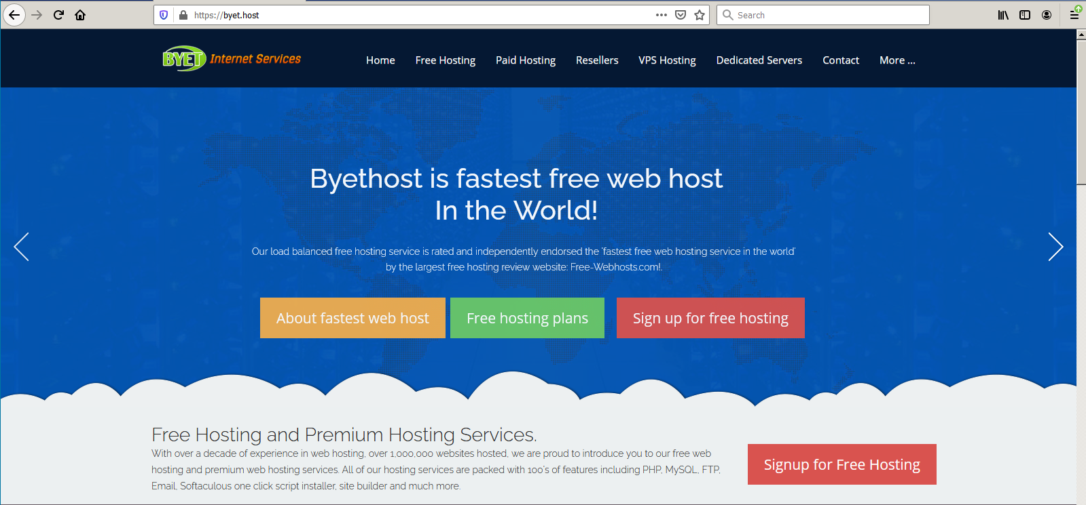
- Fill in the form.. Save the sub Domain Name and Password
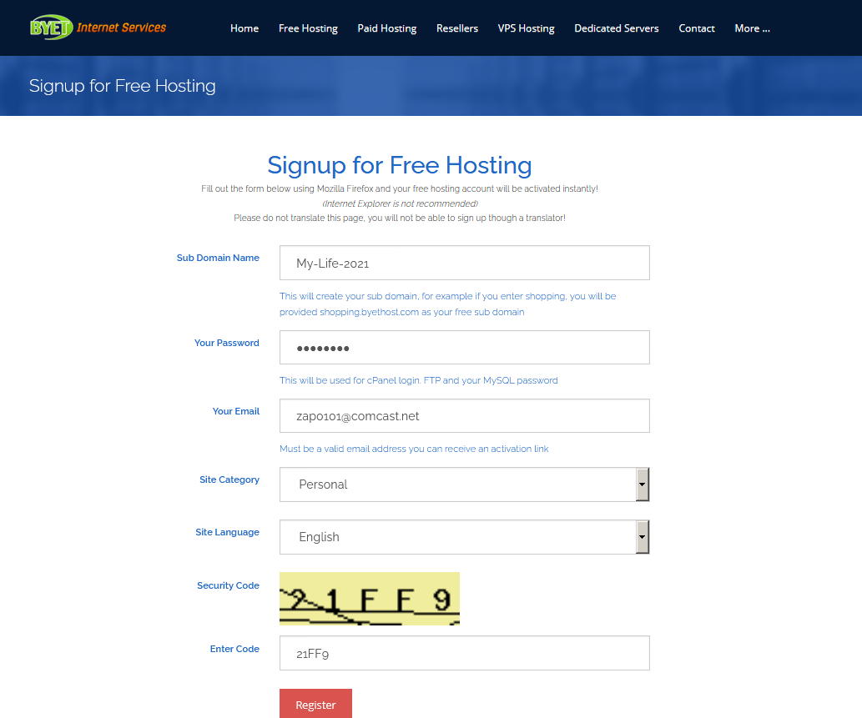
- You get a page like this
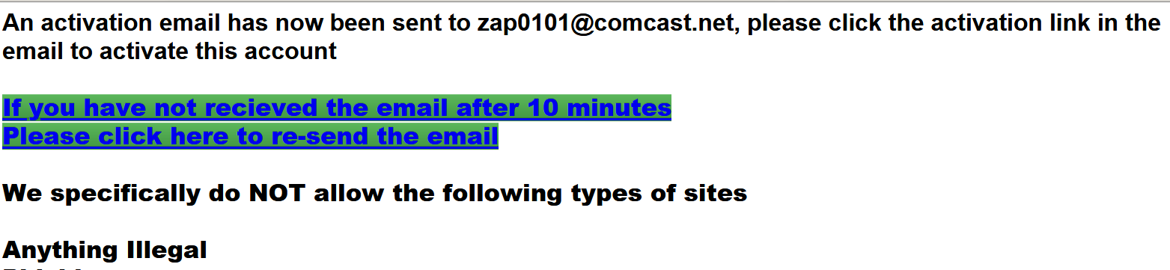
- When you get the activation email, open it and click the activation link. It may take a couple of min
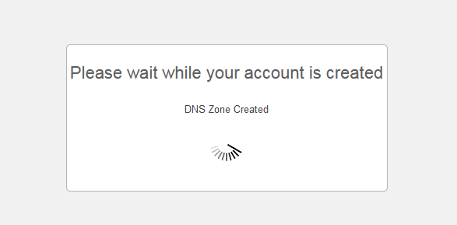 It takes a couple of minutes to activate. But then you get your access…

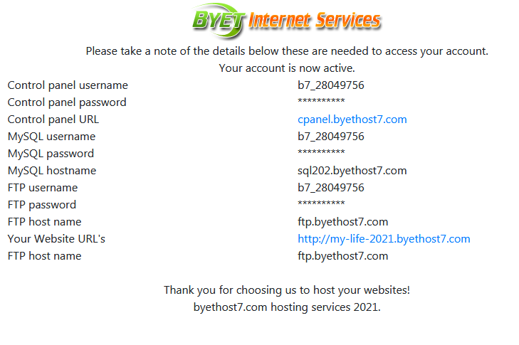
6) Make a copy of this information!!!! (the Password is what you created above)

Control panel username: b7_28049756
Control panel password: **********
Control panel URL: cpanel.byethost7.com

MySQL username: b7_28049756
MySQL password: **********
MySQL hostname: sql202.byethost7.com

FTP username: b7_28049756
FTP password: **********
FTP host name: ftp.byethost7.com

Your Website URL's: http://my-life-2021.byethost7.com
FTP host name: ftp.byethost7.com

- Click on the link to Control panel (email updates are up to you)

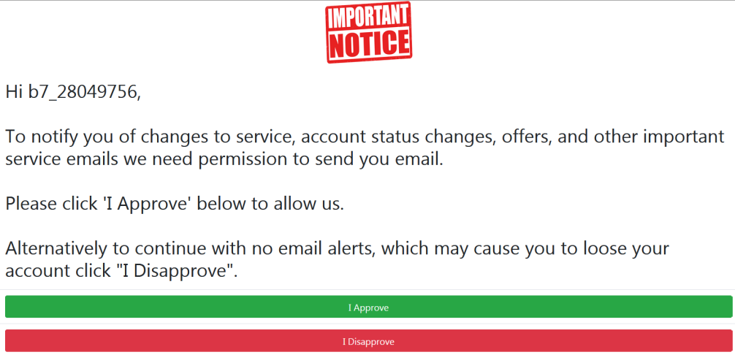
- I went to online file manager
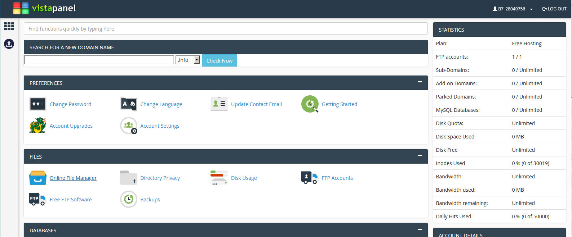
- In File Manager, open the htdocs folder
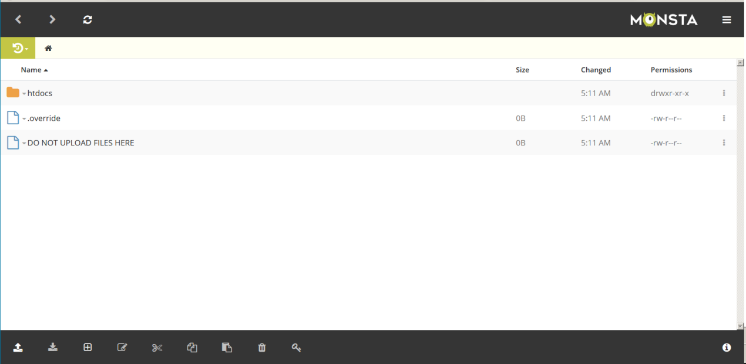
- Use the upload tool to get your files
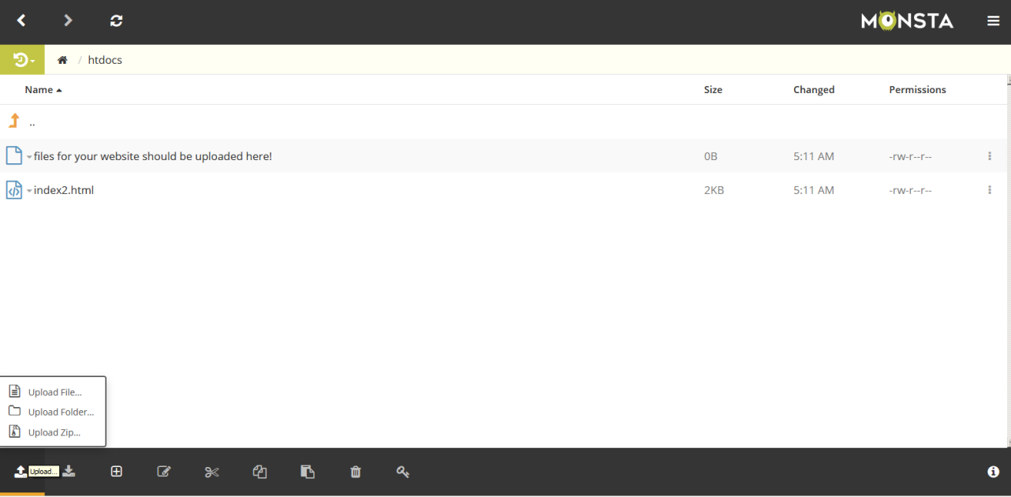
Upload all folders and files…
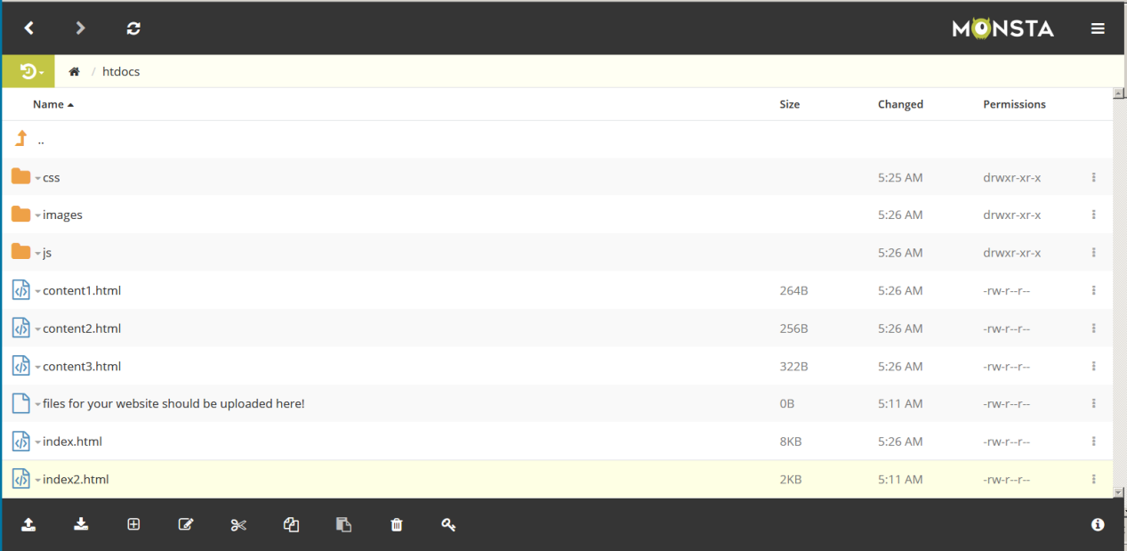
Test your site…
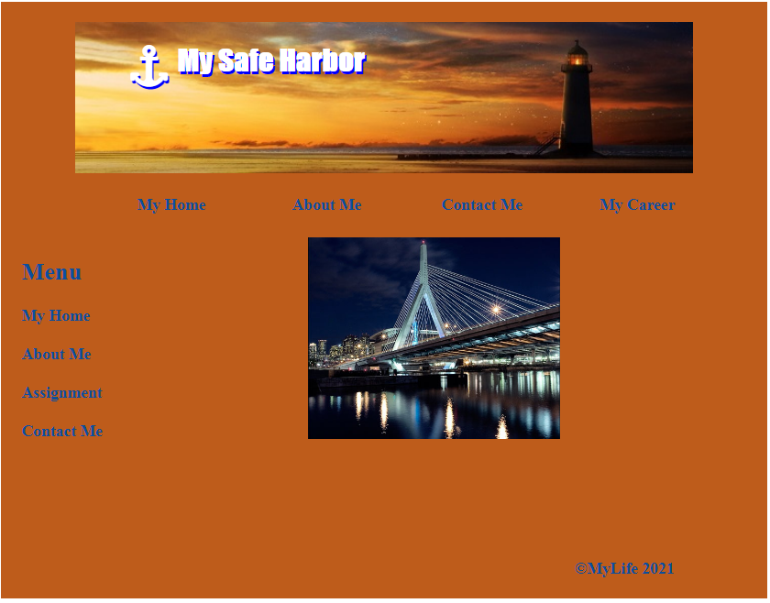
You should be done

