000webhost - Free Web Hosting
- Go to
https://www.000webhost.com/
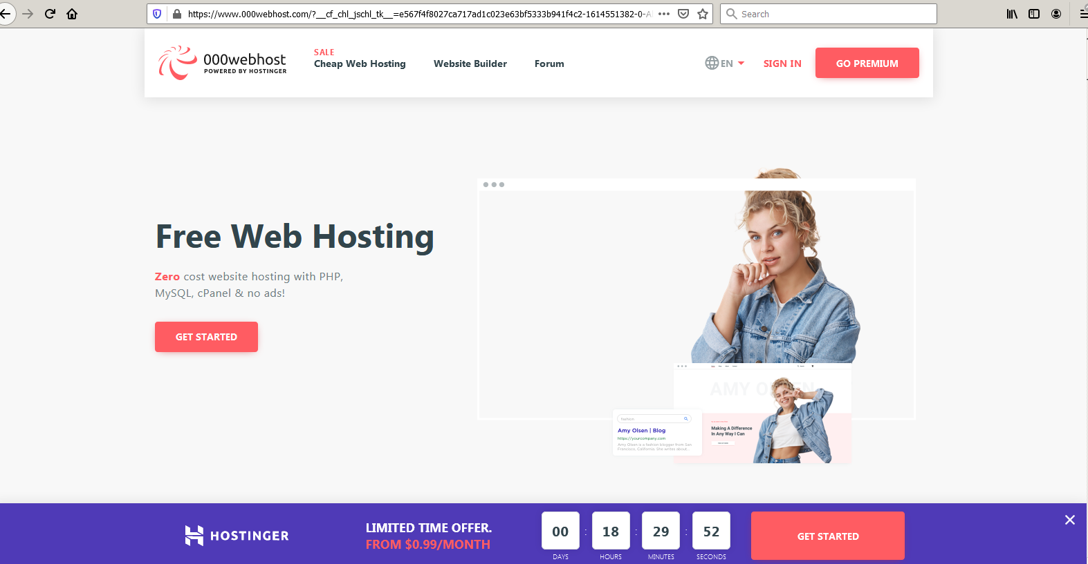
- Choose $0.00 - free sign up
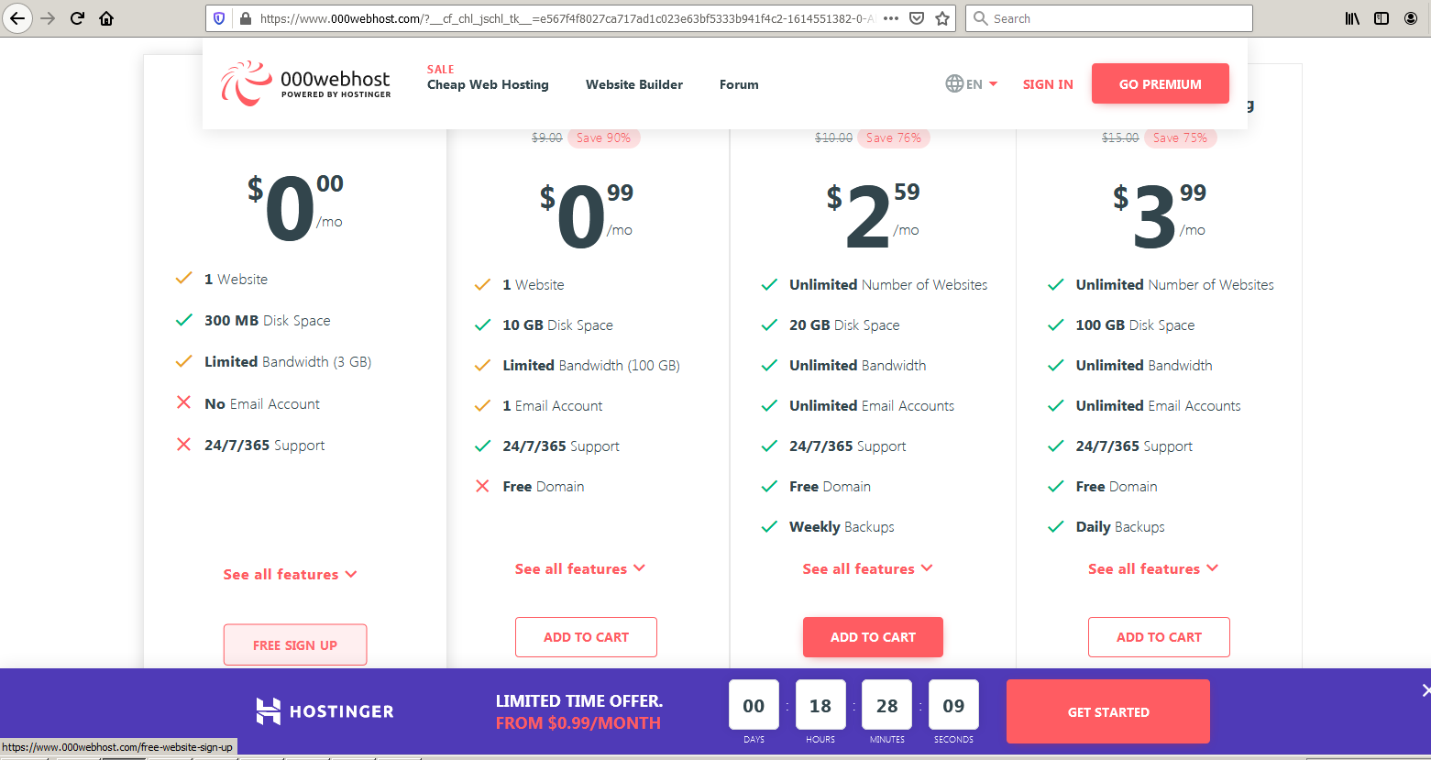

- Sign up… your email and password…
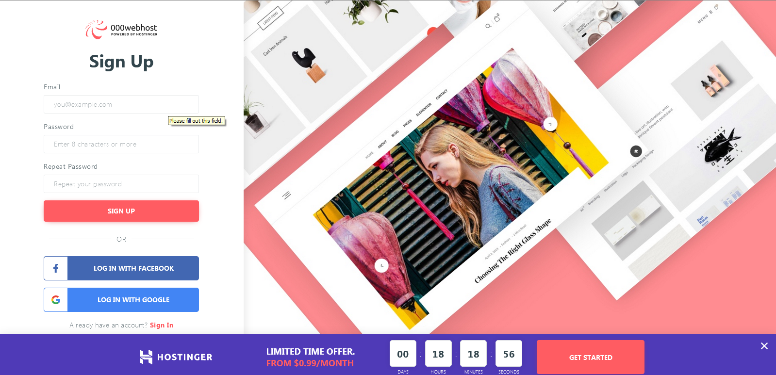
3a) This Set-up may take a couple of minutes (it took about 5 min for me)

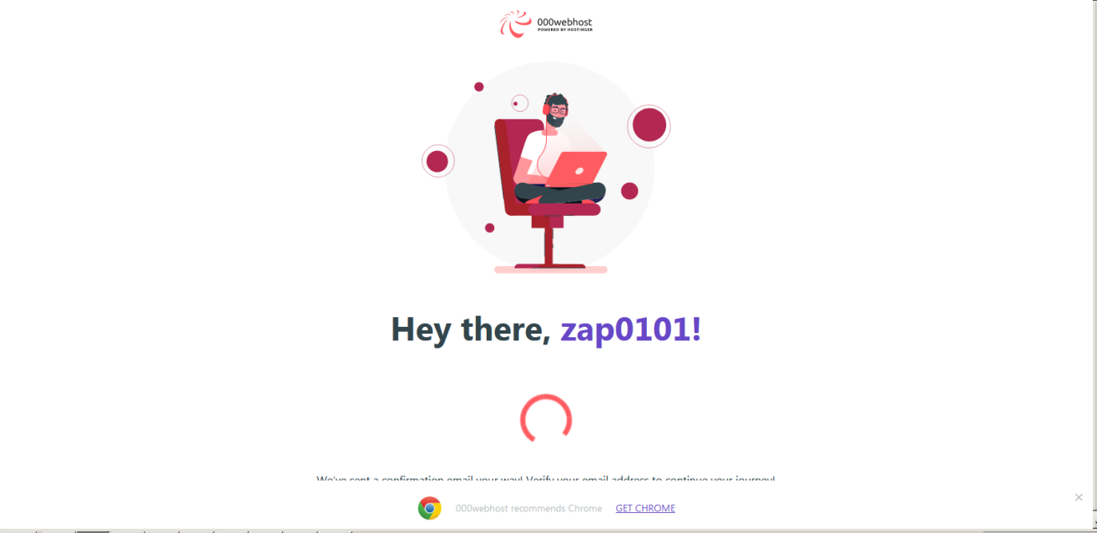
Let's Create some magic <= instructions
It’s not my first rodeo, take me to the Panel. <= or no instructions
They like Chrome
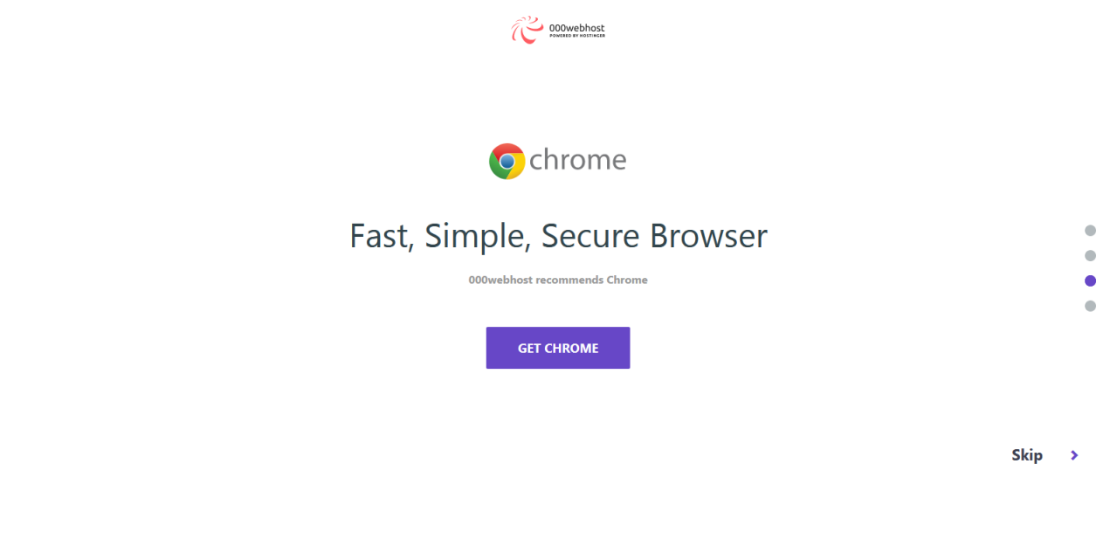
They definitely prefer chrome… but I used Opera w/o issues
- Several choices… I went straight to File Manager…
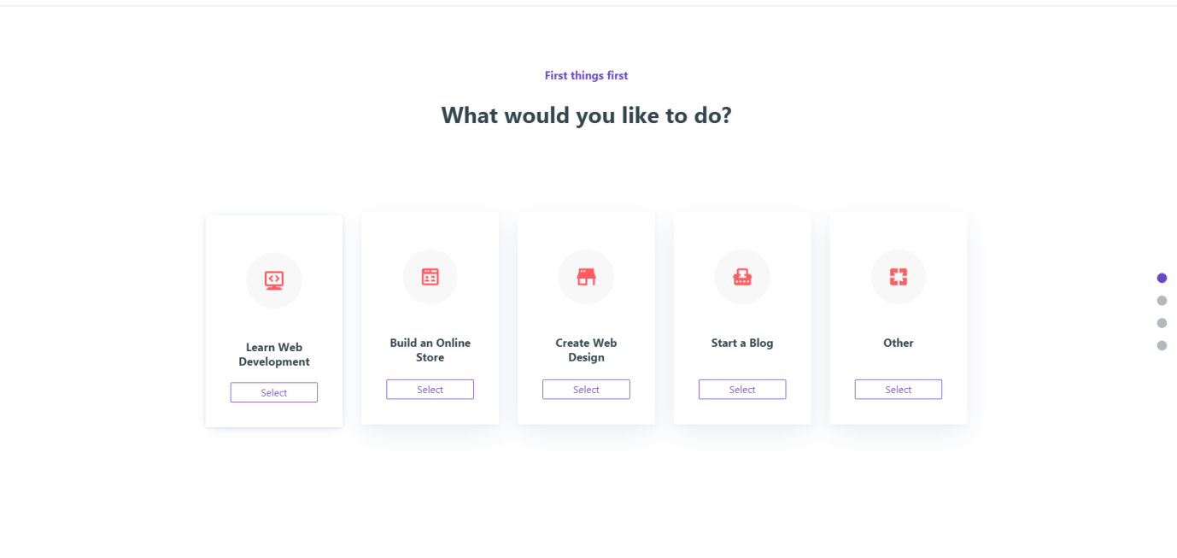
- This part was a little quirky… you should create a name… lots of restrictions… keep the password…
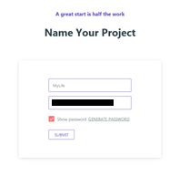
Save the name and password – you will need it
- Next upload your html/css/js/images…
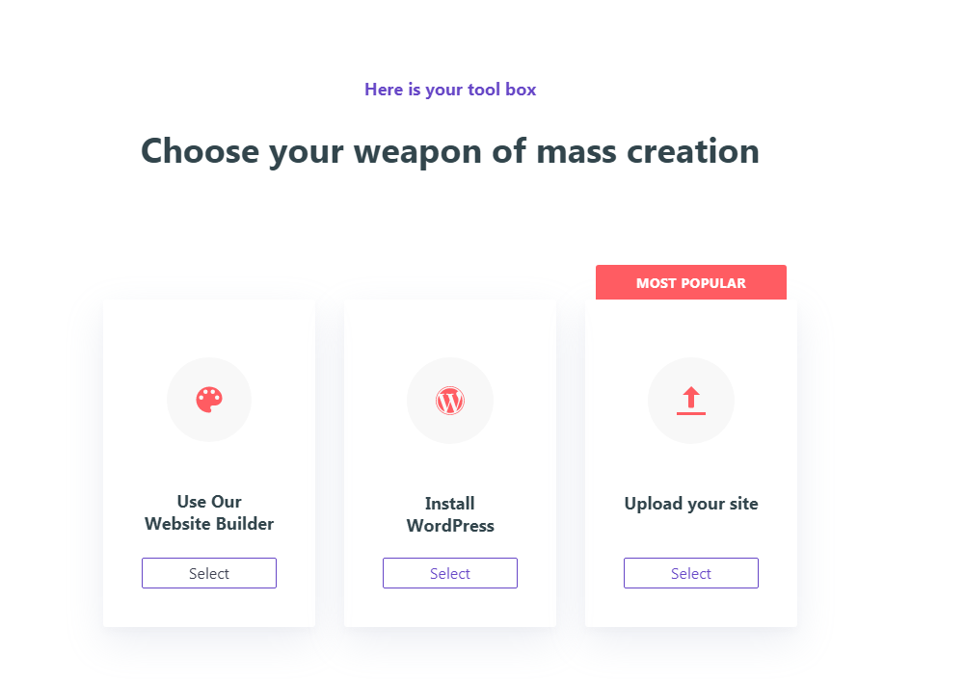
7) go to File Manager…
Use the Name and Password you just created ..2 steps back…

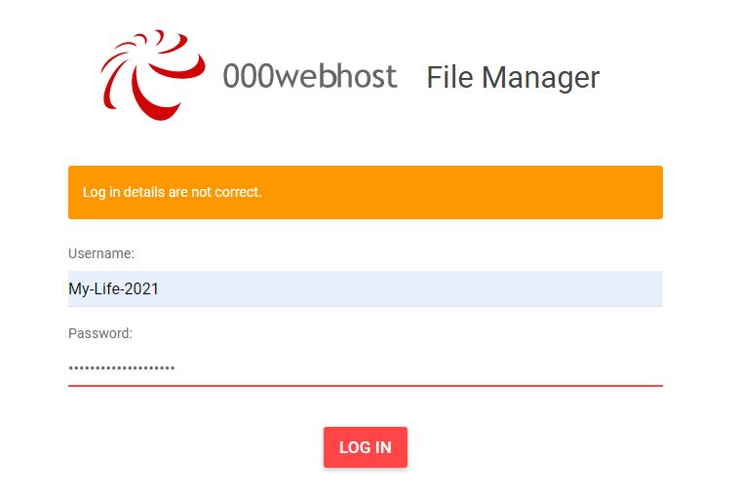

7a) Now that you are in the File Manager… go to the public_html folder… open it.
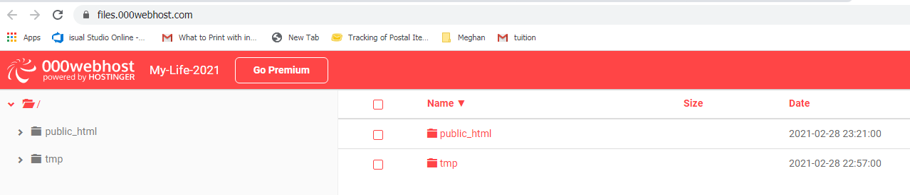
7b) Create (or upload) and test an index.html file…
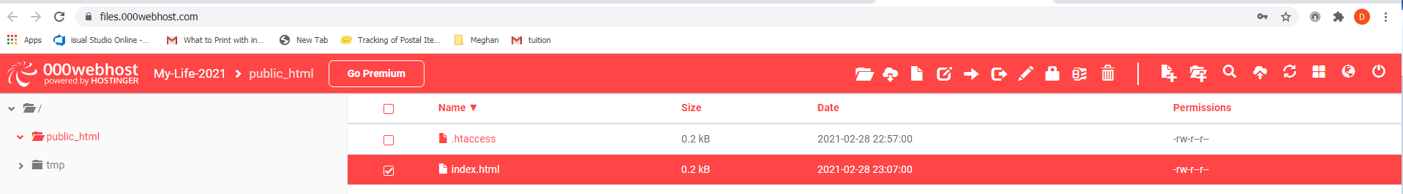
Optional…I added a test index.html file to see if it worked
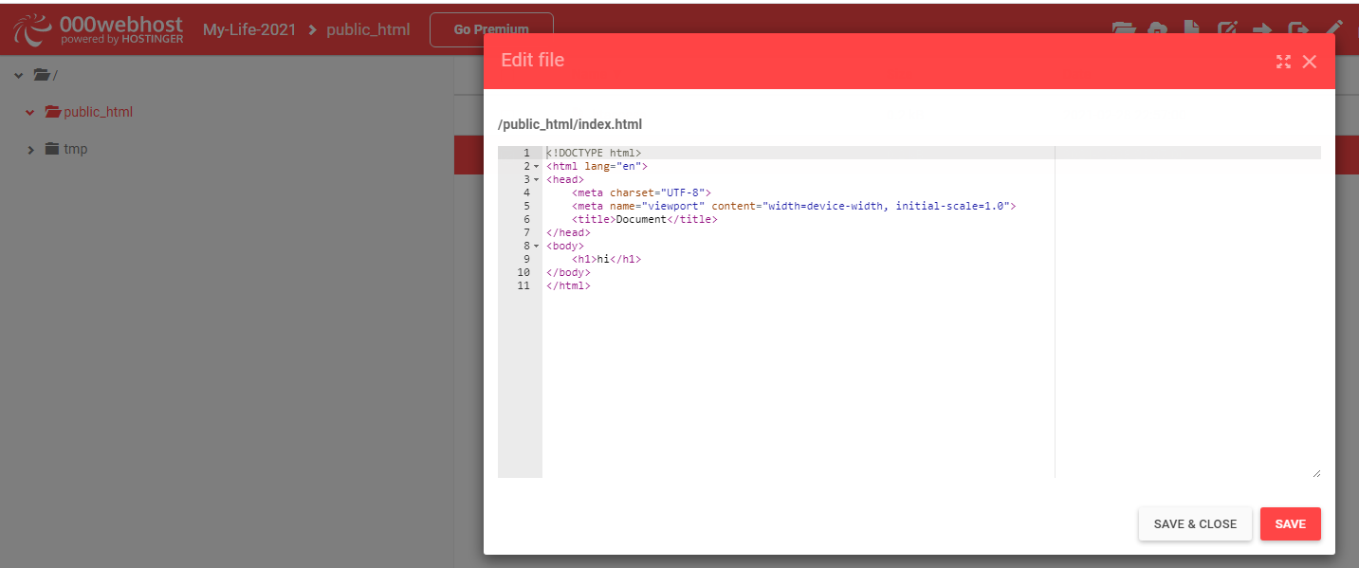
- Test your site…
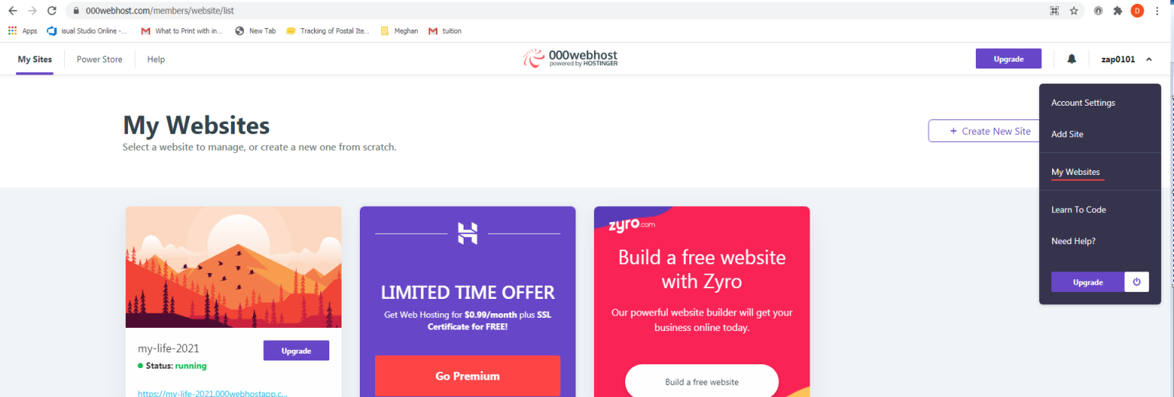

my-life-2021.000webhostapp.com

http://my-life-2021.000webhostapp.com/
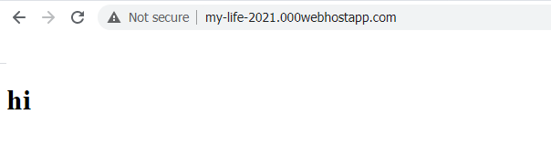
- If everything works… upload all your real content… overwrite the test index.html file
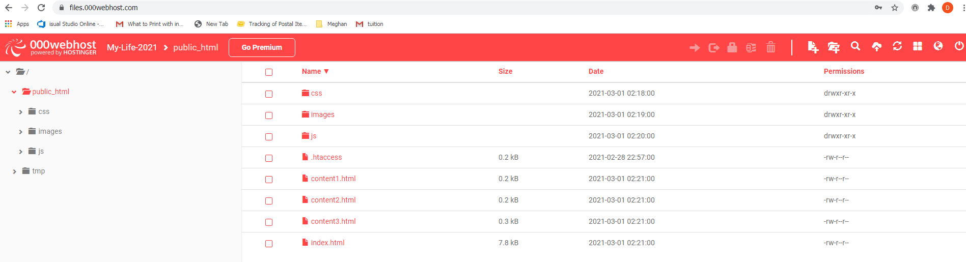

http://my-life-2021.000webhostapp.com/#


