AwardSpace - Free Web Hosting
- Go to https://www.awardspace.com/
- select Free Hosting

- Complete the sign-up form. Save the info for future use..
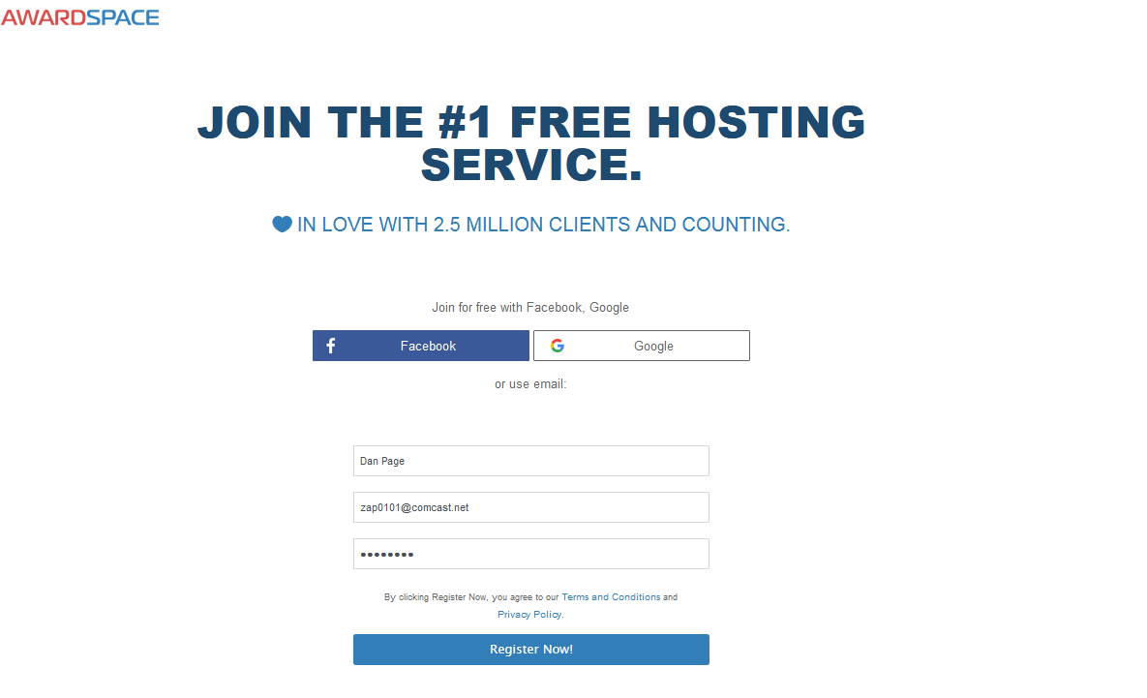
- When you get the activation email, open it and click the activation link. It may take a couple of min
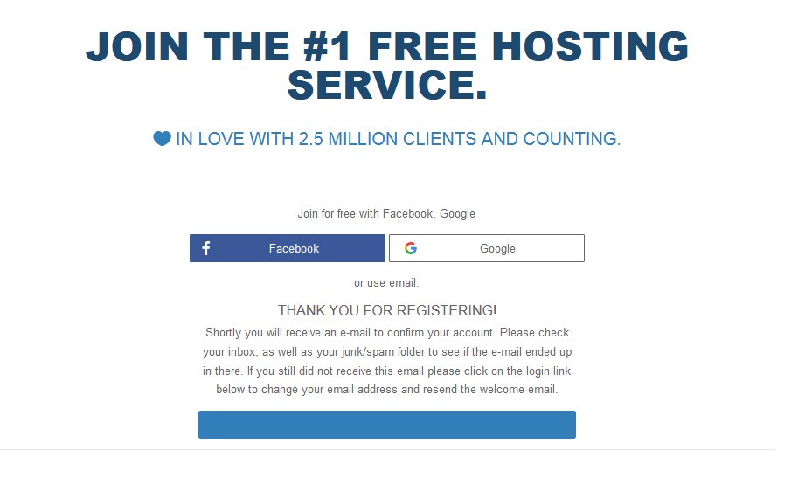
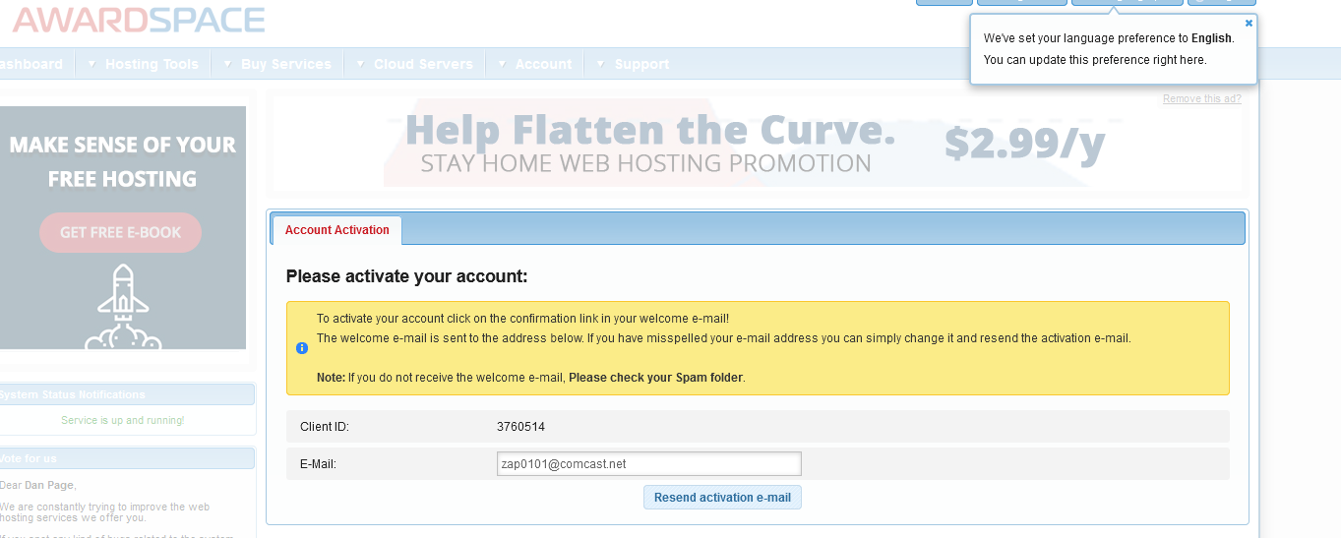
Once activated, You go straight to the Control Panel Dashboard
- Start by creating a domain (or free sub domain)
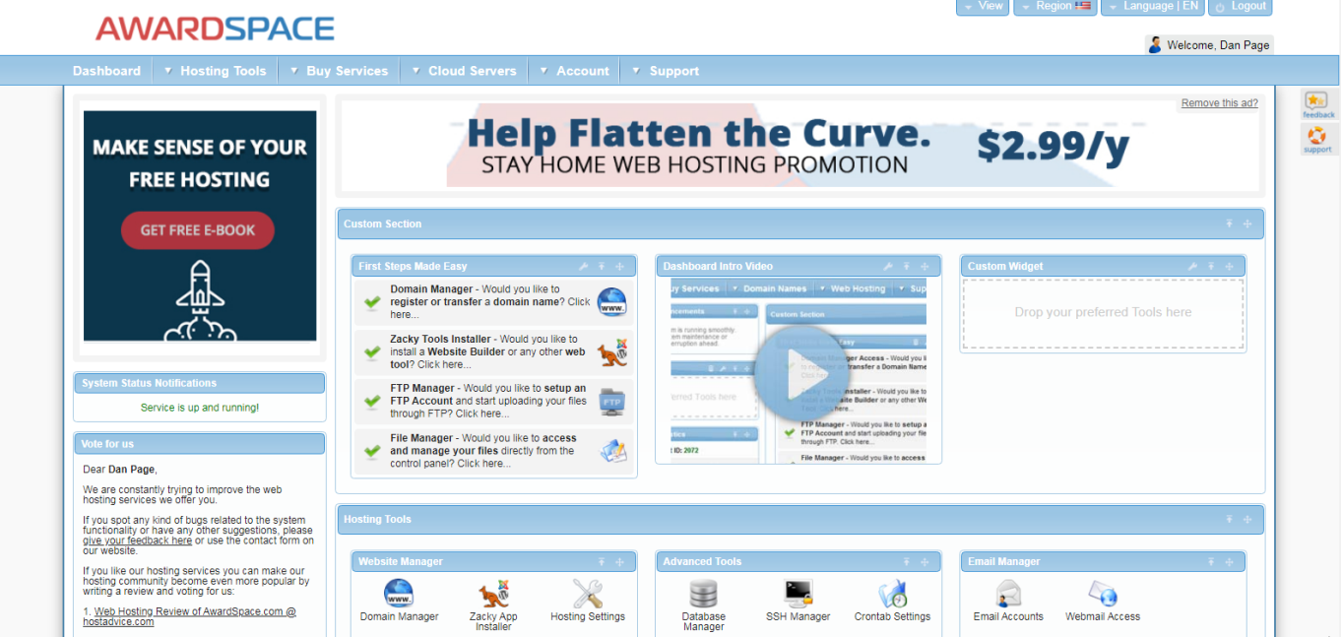
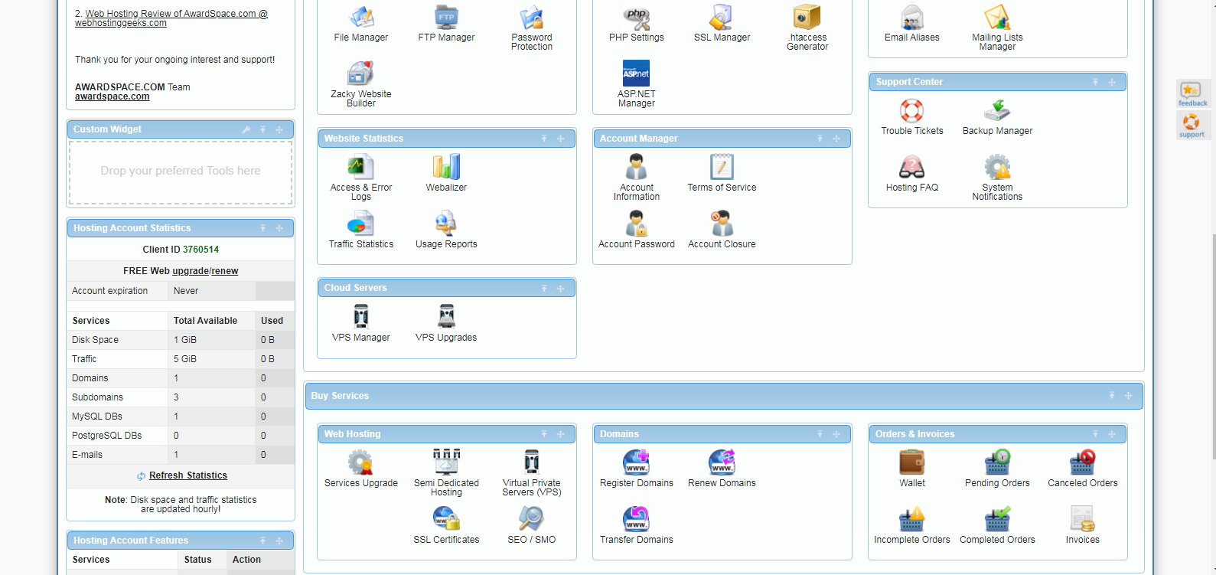
Or use the top menu
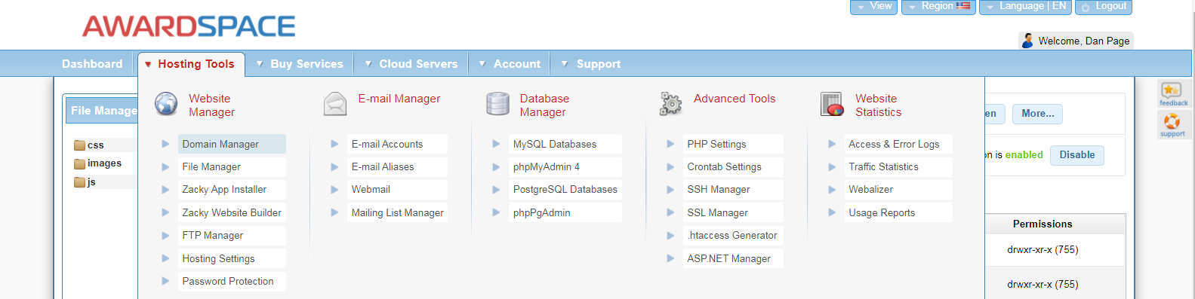
- In the Domain Name panel select a Domain type
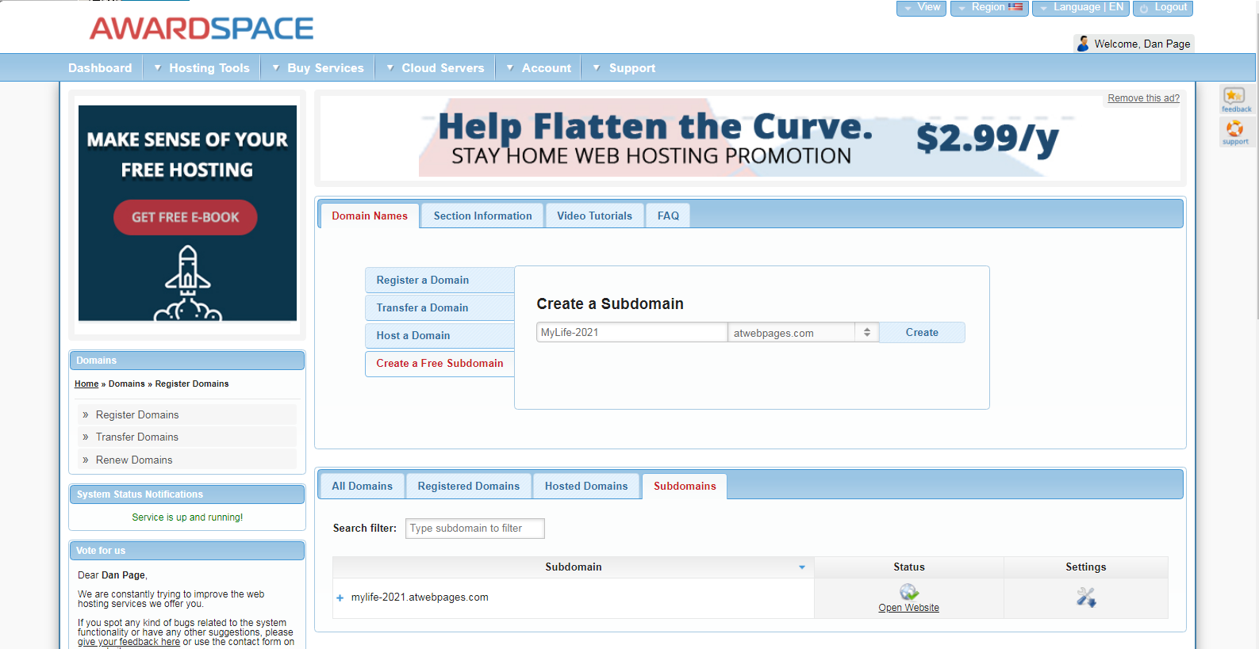
- Once you have a Domain (or Sub-Domain), go to File Manager to upload your folders and files
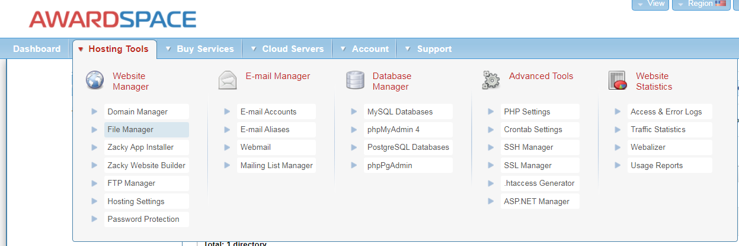

You will see your folder… open it
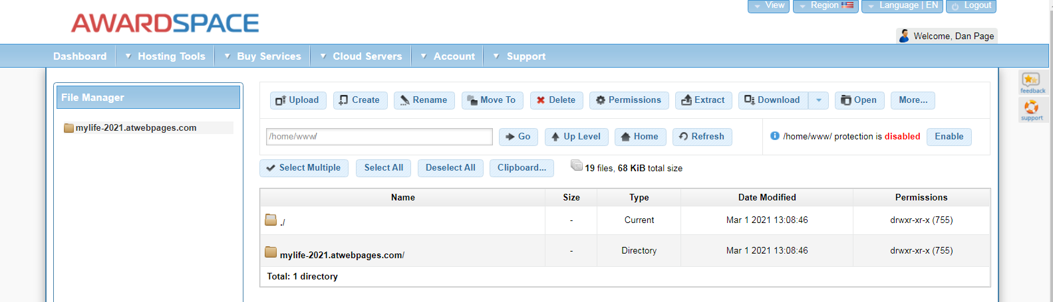
You should be able to create folders and drag/drop files
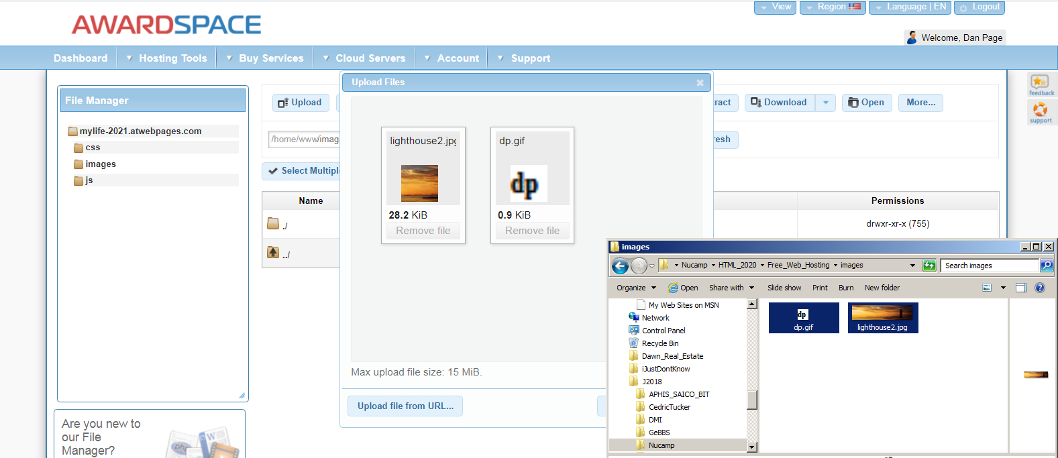

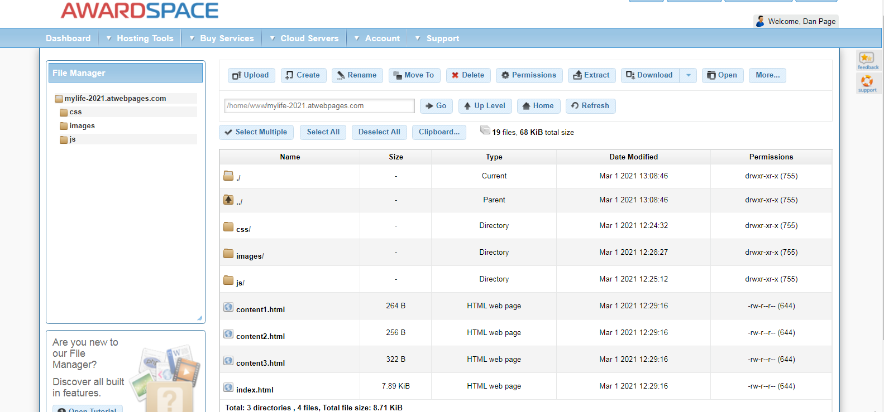
Test your site once you have completed the upload

http://mylife-2021.atwebpages.com/#
